A Coffee Shop Adventure
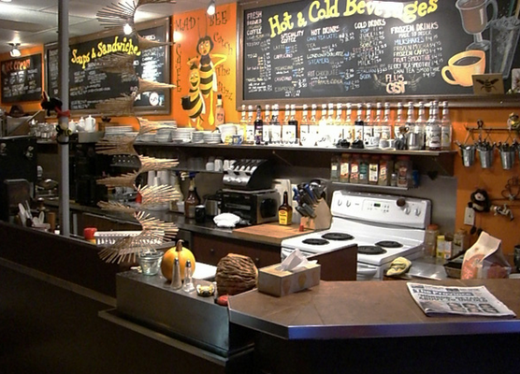
喝咖啡，聊英語

Tina is inside a coffee shop with her friend Gary, who knows little about coffee.
Gary: There are so many choices. I have no idea what to get.
Tina: Well, the differences are in the way the different cups of coffee are prepared. Espresso is just a very small cup of strong black coffee, but cappuccino is espresso mixed with frothed milk. Latte is espresso with steamed milk, and mocha is a variant of latte, with chocolate mixed in.
Gary: I really love chocolate, so maybe I’ll have one of those.
Tina: All right, I’ll order you a mocha latte, and I’ll get a cappuccino for myself.
(Tina orders at the counter.)
Tina: Hi! Could I get a large mocha latte topped with whipped cream, and one medium cappuccino with a sprinkle of powdered cinnamon?
Clerk: Sure. Did you want any flavorings or sweeteners added?
Tina: No, thanks. I’ll take my cappuccino unsweetened. What about you, Gary? Did you want anything?
Gary: I’d like to try it before I add any sugar.
Clerk: In that case, you can serve yourself with the sugar and syrup on the condiment table behind you.
Gary: Super!
Clerk: We’ll call out your order when it’s ready.
(Tina and Gary have finished their coffees.)
Gary: I never thought a good cup of coffee could be so enjoyable.
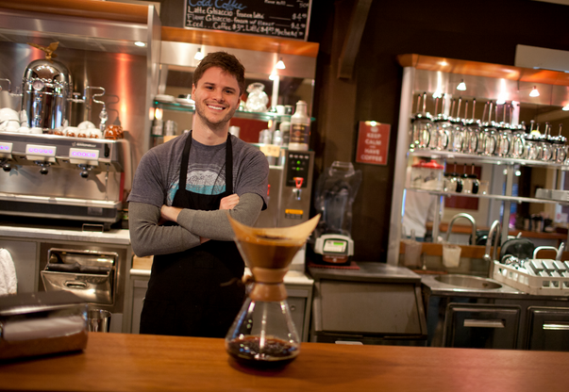
Tina: Before we leave, I want to pick up some coffee beans. They sell Sumatra Mandheling beans, which are low in acid and not too bitter. They’re my favorite.
Gary: You grind the beans at home?
Tina: Yeah. I have a coffee grinder and a French press. You should come by my place some time, and I’ll make you one of the best cups of coffee you’ll ever have!

Word Bank
froth(v.)起泡沫 (n.)泡沫,氣泡 | sweetener(n.)甜味劑,糖精
variant(n.)變化形式,變體 | acid(n.)有酸味的物質,[化]酸
cinnamon(n.)(植物)肉桂 | grind(v.)磨(碎),碾(碎)
flavoring(n.)調味品

常見義式咖啡
espresso 濃縮咖啡  (所有義式咖啡皆以此為基底,而單份劑量稱為shot) | 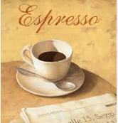
cappuccino 卡布奇諾咖啡  (類似latte,但奶泡更多,通常牛奶和奶泡各半,奶泡較多者稱為dry cappuccino,牛奶較多者則稱為wet cappuccino) | 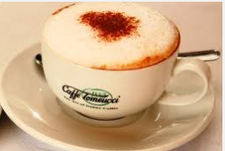
latte 拿鐵咖啡  (亦稱作caffe latte) | 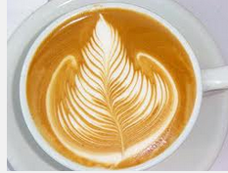
mocha 摩卡咖啡 | 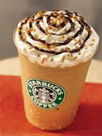
Americano美式咖啡  (加水稀釋的espresso) | 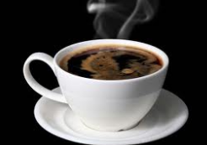
Reference: All Plus Magazine

