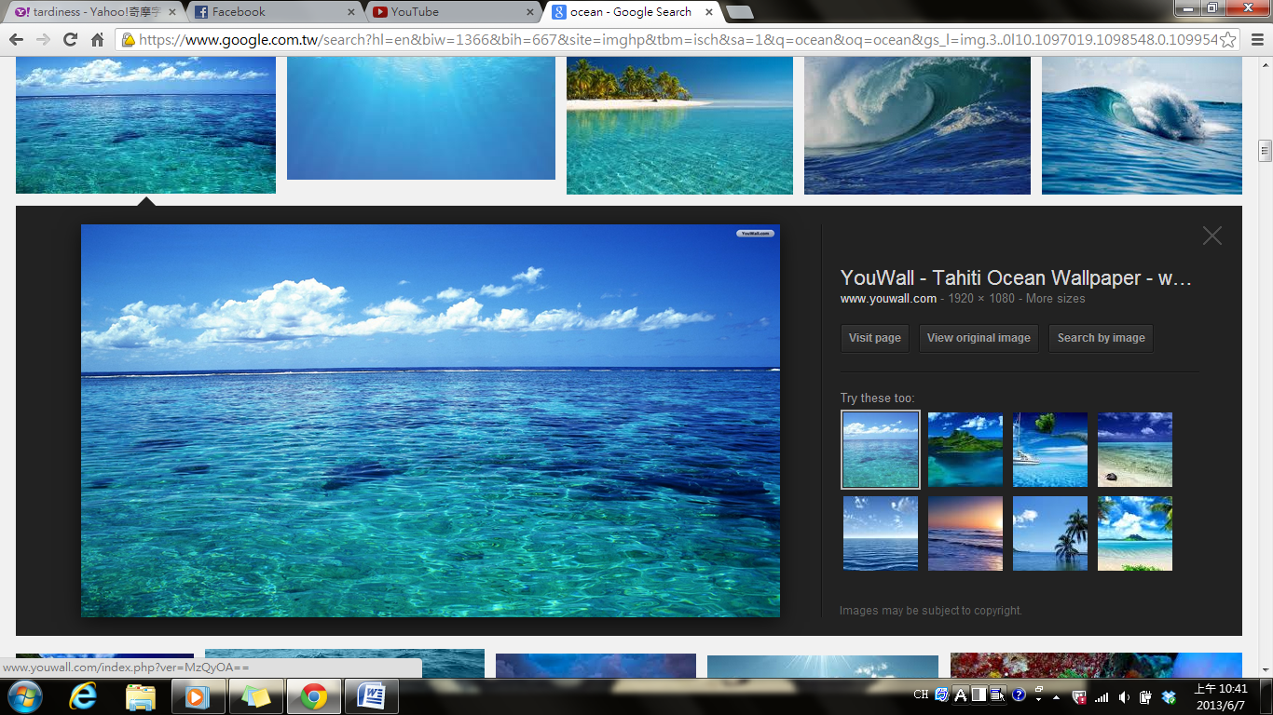
Shades of Blue:
How the Ocean Gets Its Color
為什麼海是藍色的?
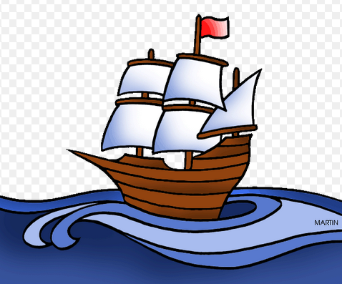
Have you ever wondered why the ocean is blue? Well, the answer isn’t so simple. First, think of a rainbow. It shows that light is made up of many colors. The reason why any material has color is that it can’t absorb some colors of light, except for yellow. It reflects that yellow light back to our eyes. The same idea applies to the ocean, which doesn’t absorb blue well.

Not all areas of the sea are completely blue, though. Some are green or blue green. This is usually caused by the presence of organisms in the water that don’t absorb green light. Remember, however, that we’re talking only about how the ocean looks from above. Beneath the surface, the ocean looks darker and darker the further down we dive. At extreme depths, the water looks completely black. That’s because there’s no light to reflect off of the chemicals and organisms in the water. Therefore, the ocean isn’t actually always blue- it just appears that way most of the time!
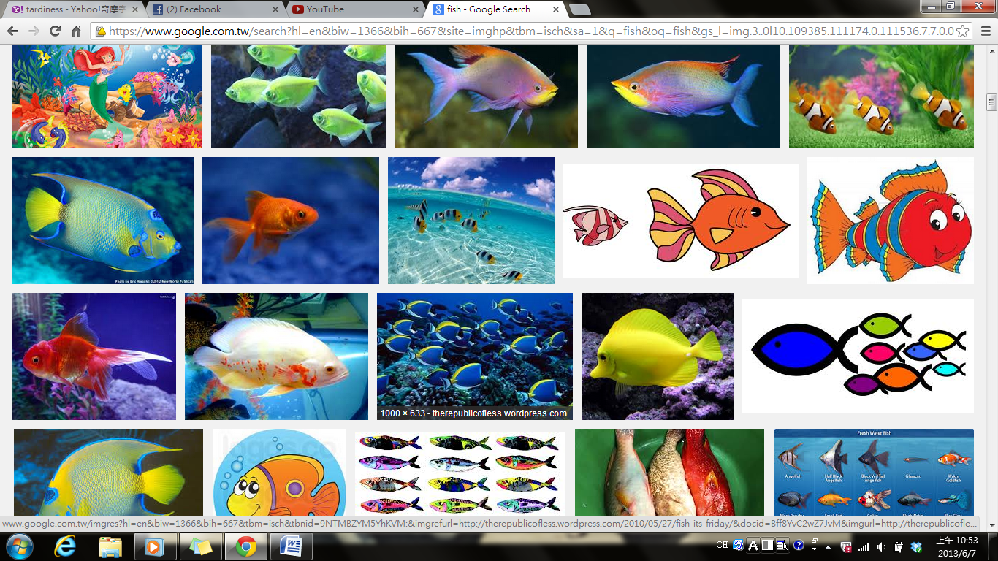

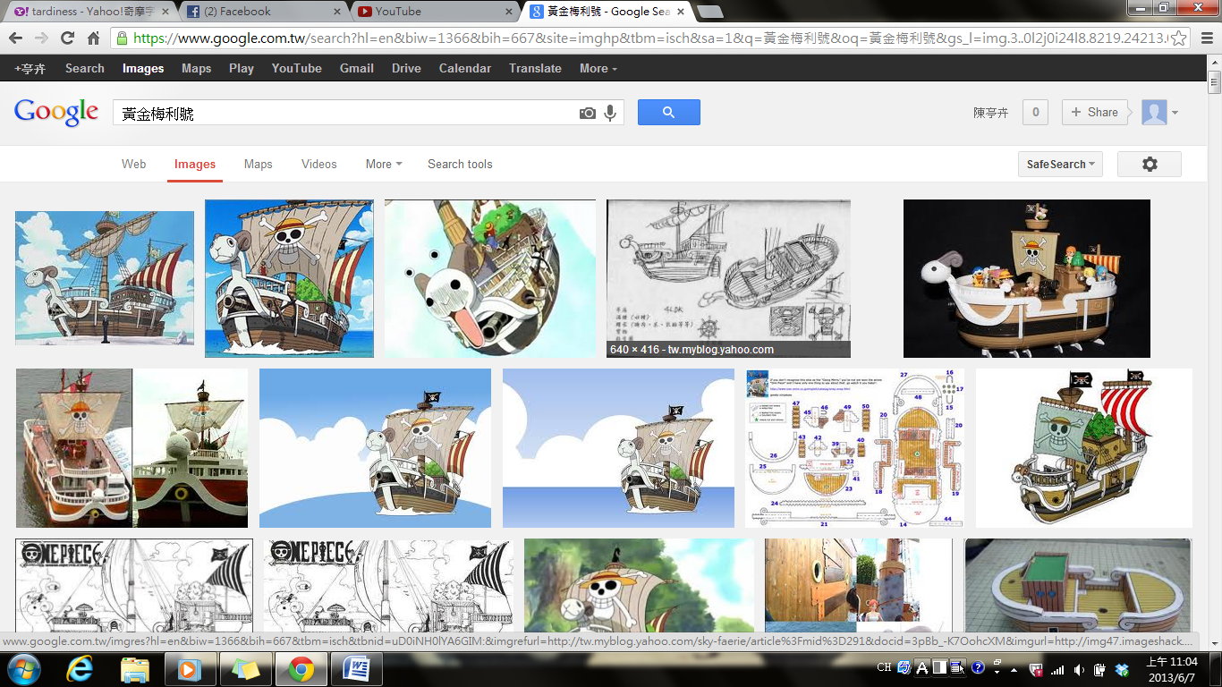
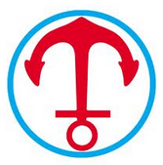
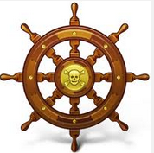

Word Bank
shade (n.)(色彩的)濃淡,色度 | apply to 適用於,應用
absorb (v.)吸收 | organism (n.)微生物,有機體
except for 除了…以外 | dive (v.)潛水,跳水
reflect (v.)反射,倒映 | most of the time在多數情況下
Reference: Live Interactive English Magazine

