
Tardiness Tips
別再當遲到大王了！！！
Some people constantly find themselves arriving late- late to class, late to a doctor’s appointment, or late to a meeting with friends. This pattern can impact a person’s self-esteem and prevent them from gaining the trust of others. Why can’t some of us break this bad habit? The answer, as well as the solution to the problem, varies from person to person. The first step is identifying the root cause of one’s tardiness.
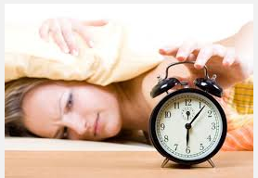
Once we’ve figured out why we’re late, how do we go about making a change? People who are late because they’re bad at estimating time can keep track of how long it takes for them to complete tasks. If they record the time of everything they do for a few weeks, they soon will have the data to better schedule their days.
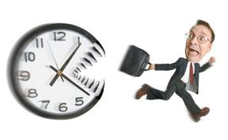
People who consistently arrive late for psychological reasons likely have to tailor their solution to their individual situation. For example, if they’re late because they can’t stand downtime, they might try bringing a book or taking time to chat with friends on their phone while they wait. People who feel a sense of accomplishment when finishing tasks just before a deadline should admit that their plan often fails and they end up late. Those who are late in order to make a statement about personal freedom need to realize that their rebelliousness isn’t doing them any favors with their viewed as rude, and people can do serious harm to their relationships.
It’s crucial to take a realistic approach to the problem of tardiness. By doing so, even the most chronically late people can take positive steps toward punctuality. Latecomers shouldn’t delay- the time is right to change their ways.
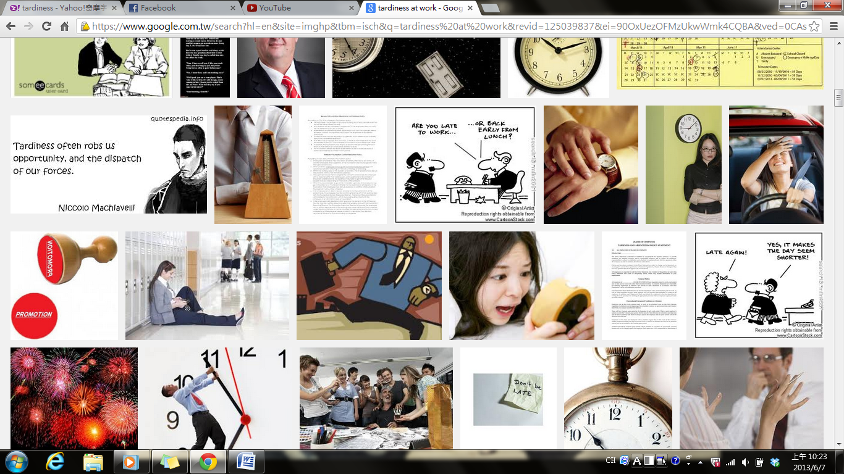

Ｗｏｒｄ Ｂａｎｋ
tardiness (n.)拖拖拉拉,延遲 | tailor (n.)量身打造,修改(細節)
pattern (n.)模式 | downtime (n.)停工時間,停機時間
self-esteem (n.)自尊,自負 | deadline (n.)截止期限
identify (v.)識別,確認 | rebelliousness (n.)叛逆
go about+Ving 開始做…,著手處理… | chronically (adv.)積習難改地,長期地
consistently (adv.)持續連貫地 | punctuality (n.)準時,守時
Reference: All Plus Magazine

