Yongkang Street: Where Food and Culture Meet
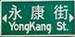
漫步永康街: 美食與人文的饗宴
These days, food lovers looking to experience a few of Taipei’s best eateries head to Yongkang Street. Located in the city’s Daan district(大安區), this neighborhood offers visitors delicious dining choices. What’s more, it’s an interesting area for exploring various aspects of Taipei’s culture.
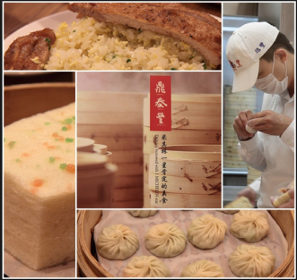
At the street’s northern end is the original branch of the Din Tai Fung(鼎泰豐) restaurant chain. Since this brand began in 1958, it has become a Taiwanese institution, known for its juicy, pork-filled steamed dumplings. It has even been named one of the world’s top ten restaurants.
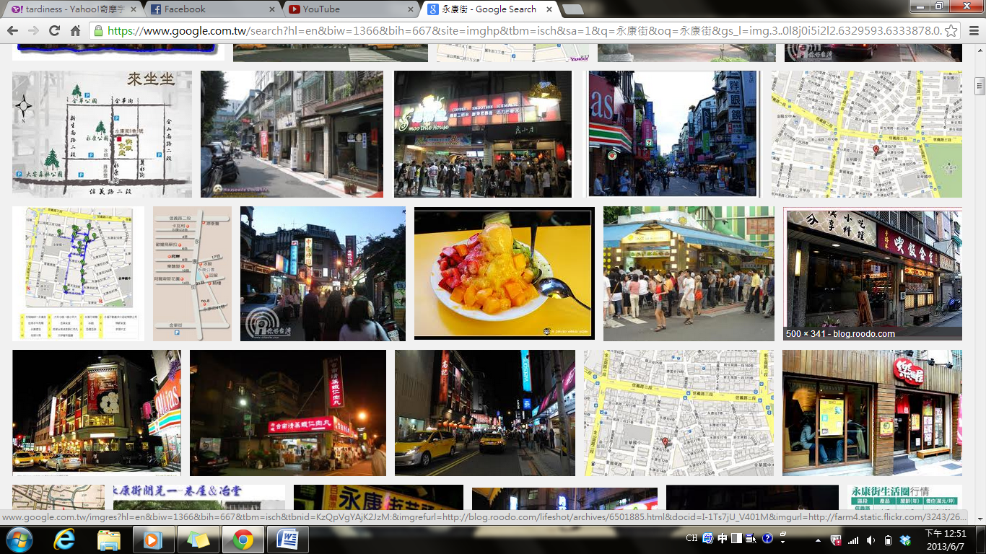
After tasting such savory dishes, you may want to treat yourself to some sweet, icy goodness. If that’s the case, then go to Smoothie House(思慕昔). This store serves heaping plates of fruit-covered shaved ice that is perfect for capping off your dining experience. Otherwise, there are several cafes and bakeries in the alleys, where you can buy cute little cakes and pastries.
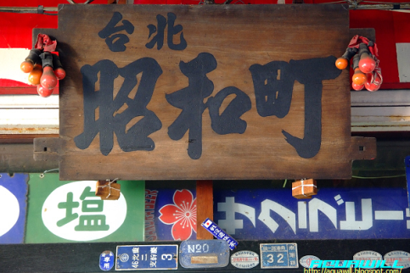
Yongkang Street is also fun for simply wandering around and for treasure hunting. At the southern end of the street is the Zhaoheting(昭和町) Antique Market. It has over twenty antique stores packed with old toys, home objects, and furnishings, many of which date back to the era when Taiwan was under Japanese control. You can also explore nearby Qingtian Street with its old buildings and stop by the historic site Qingtian 76(青田七六) for some cultural knowledge.
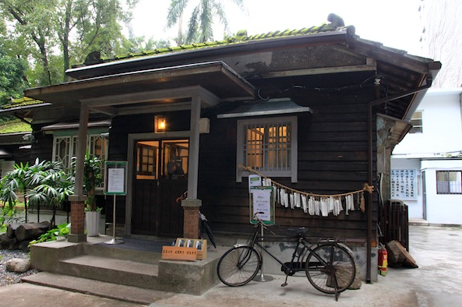
Hidden on the corner of a small lane are stairs leading to the shop Di Xia Jie(地下街). In this underground world, you can find lots of old movie posters, vintage books, and collectible pins and other small items.
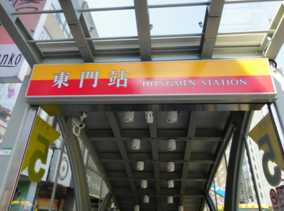
After walking around crowded streets, it’s a pleasure to get a breath of fresh air, and nearby Daan Park is the place to do just that. If you’re too tired to walk, the newly opened Dongmen MRT station, just steps away from Yongkang Street, makes getting to and from this neighborhood a breeze. Next time you’re looking for a remarkable meal and a pleasant way to spend the day, consider making a trip to this part of the city.

Word Bank
eatery (n.)小餐館 | alley (n.)小巷
district (n.)行政區,地區 | wander (v.)漫遊,閒逛
what’s more 而且,此外 | furnishing (n.)家具,室內陳設
institution (n.)習俗,制度;文中引伸指在某一領域或地方非常知名或具代表性 | era (n.)年代
be famous/known for N./Ving 因…聞名 | vintage (adj.)古色古香的
savory (adj.)鹹香的,美味可口的 | collectible (adj.)適合收集的
heap (v.)堆放,堆積 | breeze (n.)微風; 在文中用來比喻為輕而易舉的事
cap off 使…結束,使…作結 | remarkable (adj.)出色非凡的,卓越的
Reference: Live Interactive English Magazine

