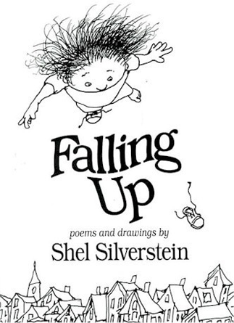
Shel Silverstein was an American poet, illustrator, screenwriter, and author of children’s books.
Silverstein was best known for his poetry and literature for children.
He was a self-taught poet and wrote in a humorous, colloquial, down-to-earth style that said a lot in a few words.

Shel Silverstein是位美國詩人，插畫家，編劇，以及童書作家。
Silverstein以他的詩作和兒童文學聞名。
他是位自學的詩人，以幽默的、口語化、言簡意賅的樸實風格創作。

