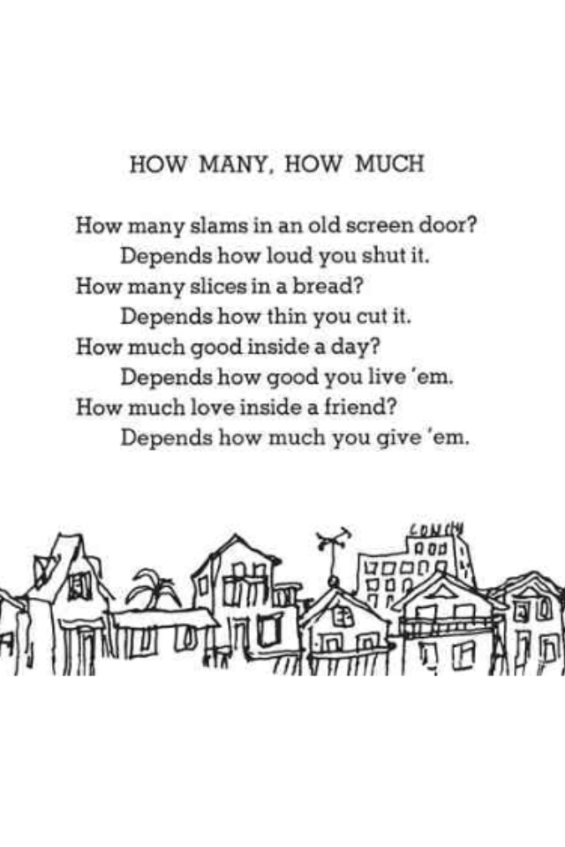
多少，有多少
How many砰響 in an 老舊的紗門？
Depends how loud you 關 it.
How many片 in a bread？
Depends on how 薄 you cut it.
How much good inside a day？
Depends how good you 過這一天.
How much love 在朋友之間？
Depends how much you付出.

The Little Boy and the Old Man  Said the little boy, ‘Sometimes I drop my spoon.’  Said the little old man, ‘I do that too.’  The little boy whispered, ‘I wet my pants.’  ‘I do that too,’ laughed the little old man.  Said the little boy, ‘I often cry.’  The old man nodded, ‘So do I.’  ‘But worse of all,’ said the boy, ‘it seems  Grown-ups don’t pay attention to me.’  And he felt the warmth of a wrinkled old hand.  ‘I know what you mean,’ said the old man. | 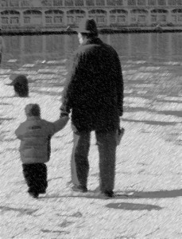
小男孩與老人

Said the little boy, “Sometimes I 掉my 湯匙.”
Said little old man, “I do that too.”
The little boy 輕聲說, “我還尿褲子”
“I do that too,” laughed the little old man.
Said the little boy, “I often cry.”
The old man 點頭, “So do I.”
“ But 最糟的是,” said the boy, “it seems
大人都不關心我.”
And he felt the 溫暖 of a 滿是皺紋的old hand.
“I know what you mean,” said the old man.

