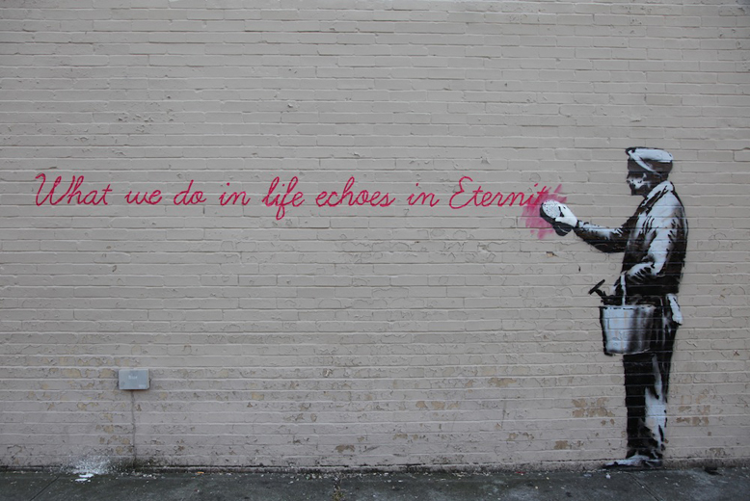
Banksy 是一位pseudonymous 英國graffiti artist, political activist, film director, and painter.
他的 satirical street art and subversive epigrams combine dark humour with graffiti executed in a獨特的模板技術拓印.

Such artistic works of political and social commentary have been featured on streets, walls, and bridges of cities 在世界各地不同城市.

