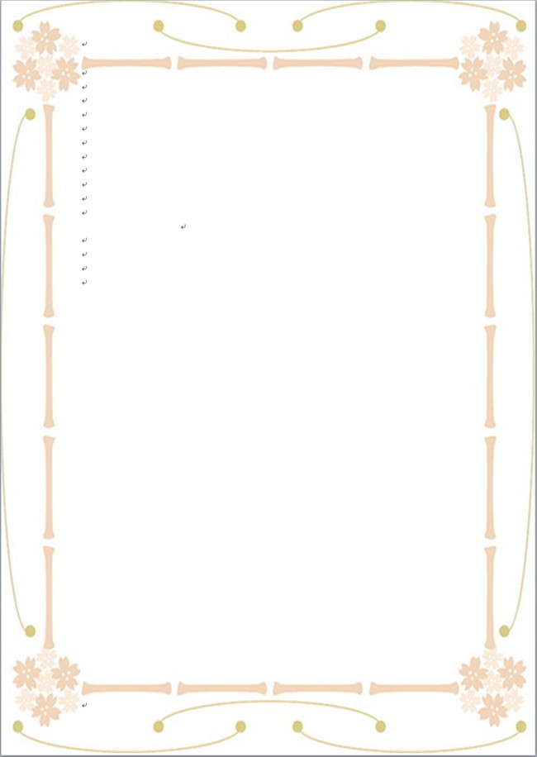
Victoria’s Secret Fashion Show: Katy Perry Banned From Performing in China

維多利亞的秘密時尚秀：凱蒂．佩芮中國演出遭封殺
American singer Katy Perry has been banned from getting a Chinese visa ahead of the Victoria’s Secret Fashion Show in Shanghai, where she was expected to perform.
Perry is allegedly banned from traveling to China because of what she wore during a 2015 performance in Taipei, Taiwan：a sequined dress embellished with sunflowers. She also wore a Taiwanese flag as a cape during her show, though whether or not she intended to make a political statement either through the dress or the flag is unclear.
A source told Page Six that Perry had tried applying for a visa to enter China, but was denied by Chinese officials. They "comb through performing artists’ social media and press reports to see if they have done anything deemed to be offensive to the country."
In addition to Perry, Maroon 5 was banned a few years ago because one band member wished the Dalai Lama happy birthday on Twitter. Tibet-supporter Lady Gaga was banned after meeting with the Dalai Lama.

【WORD BANK】
allegedly：副詞，據稱，據說。
embellished：動詞，點綴，修飾。
comb through:動詞片語，徹底搜查。
取自《自由時報》: http://iservice.ltn.com.tw/Service/english/english.php?engno=1153688&day=2017-11-21

