Studies expand on soda’s role in growing obesity碳酸飲料造成肥胖?
A new set of published studies has found that removing sugary drinksform kids’ diets slows weight gain in heavy teens and reduces the odds that normal-wieght children will become obese. More than 12.5 million American kids and 78 million adults are obese.
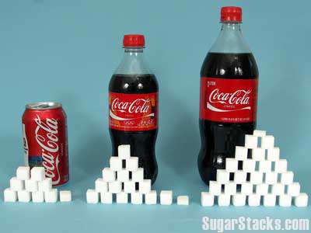
The findings provide a clear-eyed look at how weight gain is directly influenced by consumption of sugary drinks. In one of the studies, involving 641 normal-weight children between the age of 5 and 12, those who drank 8 ounces of a sugar-sweetened beverage each day for 18 months gained more than 2 pounds of additional weight and accumulated more fat than their peers who drank artificially sweetened drinks daily.
In the other study, involving 224 ninth- and 10th-graders who were already overweight or obese, those who were supplied with diet drinks and water for one year were more than 4 pounds lighter on average-and roughly half a point lower on the body mass index scale-than their peers who continued to dring sugary beverages. But when thouse teens were allowed to revert to their old havits, the differences between the tow groups disappeared within a year.
“This research pushes us beyond the potential and suggestive effect of sugar-sweetened beverages on obesity and weight gain and into the realm of very solid science,” said University of North Carolina epidemiologist Barry M. Popkin.
While an individual’s weight may be determined by comparing calories consumed and calories expended, some experts believe calories from particular sources-including super-sweetened drinks-may have effects beyond the simple units of energy they contain, Dr. David M. Harlan, a leading expert on obesity and diabetes at the University of Massachusetts Medical School said.

**Word Bank**
obese (adj) extremely overweight
clear-eyed (adj) to have mental sharpness and be perceptive
revert to (phr v) to go back to a previous condition
epidemiologist (n) a physician who studies how and why disease spread and how they can be controlled
expend (v) to use or spend something, especially time, effort or money
diabetes (n) a disease in which the body cannot control the amount of sugar in the blood

Reference: Advanced

