What Causes Earthquake Swarm ?
「群震」的成因為何？

Seismic activities can be classified into either a major quake followed by aftershocks or an earthquake swarm. In general, within major earthquakes a maximum-scale quake is followed by a number of minor aftershocks. Meanwhile, the swarm earthquake is a series of the quakes of a similar scale to the mainshock.
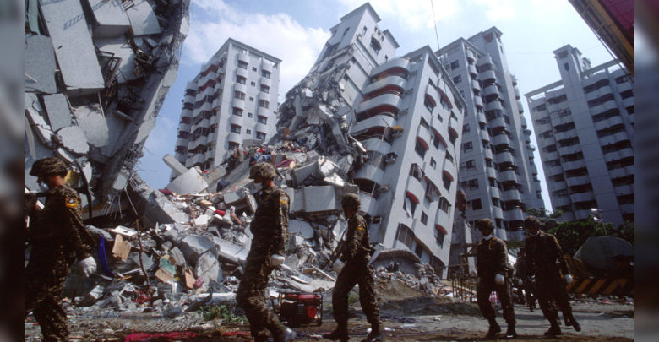

The AD 2000 Izu islands earthquake that struck the northern Izu islands showed one of the most energetic swarms ever recorded. We analysed the seismicity data as well as the land survey of this swarm to demonstrate that the sustained crustal deformation and increase in stressing rate largely contribute to the occurrence of earthquake swarms.

Earthquake swarm has been considered to be "an exceptional phenomena" which differs from the normal earthquakes. Dominant hypotheses that explain the occurrence of the swarm include the immediate influence of magma and ground water (ex. intrusion to the fault), peculiar inhomogeneity of crustal structure and so on.

【Word Bank】
aftershock：名詞，餘震。
mainshock：名詞，主震。
seismicity：名詞，地震活動。
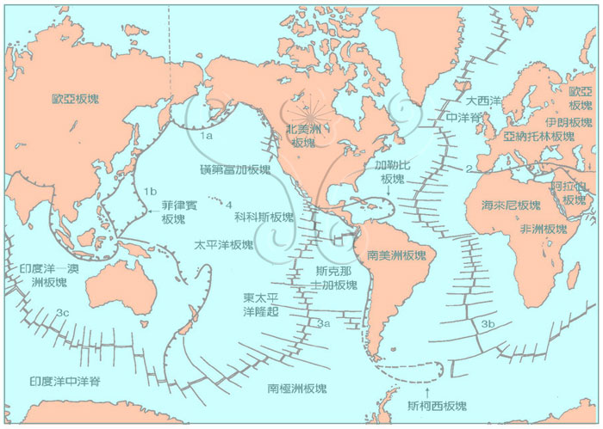

取自自由時報
http://iservice.ltn.com.tw/Service/english/english.php?engno=1176706&day=2018-02-12

