FLIP-FLOPS FAIL AS FOOTWEAR
啥! 夾腳拖會傷腳?
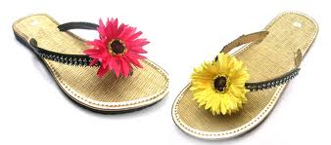
It is summer, and people are slipping on their fashionable flip-flops with little sighs of pleasure. However, some say that these sandals are harmful, not hip. Can this be true?
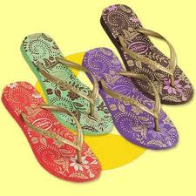
While flip-flops may seem like a casual and comfortable choice of footwear, the word on the street is that they aren’t very good for your feet, legs, or hips. According to doctors, flip-flops cause wearers to change the way they walk. Instead of landing mostly on the heel with every step, flip-flops wearers unconsciously hit the sidewalk with the outside of their feet and roll inward. This movement can weaken tendons and possibly even create stress fractures.

Injuries from a changed gait are not the only dangers with flip-flops. This loose shoe has a tendency to make people trip, leading to sprained ankles and broken bones. Flip-flops expose the foot, too, making bruised or broken toes more likely. Foot cramps are also known to occur from toes curling to keep the flip-flops form sliding off.
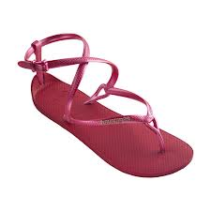
It’s amazing that such a simple sandal

fracture (n.) 骨折
bruised (adj.) 瘀青的
cramp (n.) 抽筋
+傷勢小辭典+
can cause so many problems. It may be
wise to reach for a safer shoe for the
summer.
*Word Bank*
hip(adj.) (裝扮,想法)時髦的 | tendon(n.) 肌腱
the word on the street 道聽塗說的消息 | gait(n.) 步伐
unconsciously(adv.)無意識地 | tendency(n.)傾向
inward(adv.) 向內 | expose(v.) 使暴露
-Michelle Adams

