NASA took the 1st, astonishing aerial photos of the giant new Antarctic iceberg

美國國家航太總署捕捉到首張驚人南極新巨型冰山空拍照

Each Antarctic spring and summer, NASA flies special aircraft over the continent to keep tabs on how global warming is altering the landscape.

The agency does the same in the Arctic each summer, for a project known as Operation IceBridge.

A NASA P-3 Orion aircraft flew from Ushuaia, Argentina, out over the Larsen C Ice Shelf, including the new, Delaware-sized iceberg that the shelf gave birth to sometime between July 10 and July 12 of this year. The iceberg, named A-68, was one of the largest ever observed on Earth.

The NASA images, posted to the agency’s social media accounts, constitute the first time we’ve seen this iceberg up close with the human eye.
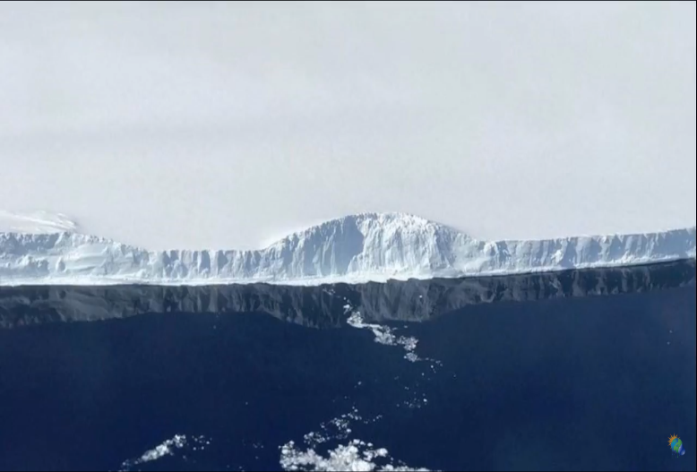

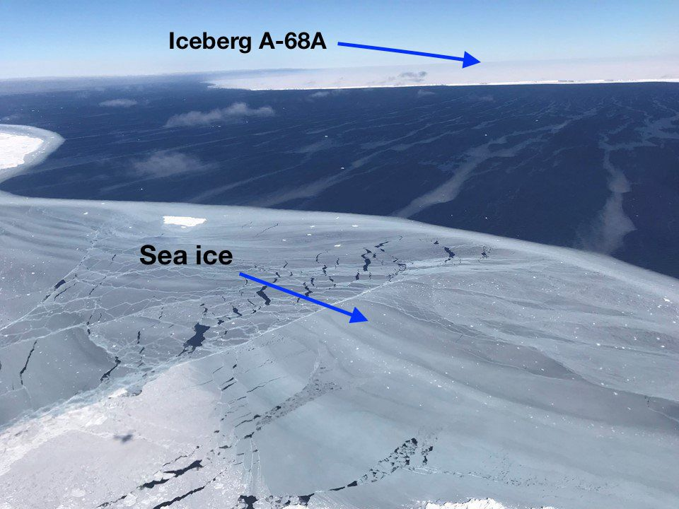
Until now, all the views of it have been with the aid of remote sensing, primarily using satellites that could pierce the Antarctic winter darkness using specially-designed instruments.

《WORD BANK》
antarctic：名詞，南極；形容詞，南極的。
arctic：名詞，北極；形容詞，北極的。
iceberg：名詞，冰山、流冰。

文章網址：http://iservice.ltn.com.tw/Service/english/english.php?engno=1157329&day=2017-12-04
圖片網址：https://www.youtube.com/watch?v=A_agXHkg9Bw
http://mashable.com/2017/11/14/nasa-first-aerial-photos-iceberg-antarctica/#f5UP6k5LPsqc

