A new coronavirus is killing pigs in China
一種新型冠狀病毒正屠殺中國豬隻

An unknown killer preying on pigs in China has been identified as a new kind of coronavirus. And like the deadly SARS virus, this one also got its start in bats.

In late 2016, pigs mysteriously started having intense diarrhea and vomiting on farms in China’s southeastern Guangdong province. By May 2017, the disease had killed 24,693 piglets.
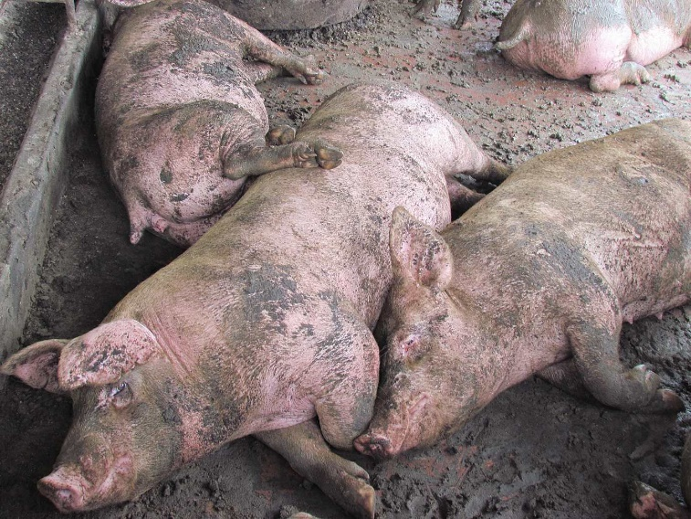

By analyzing samples from sick piglets, researchers pieced together the genetic blueprint of the virus causing swine acute diarrhea syndrome, or SADS. It shares 95 percent of its genetic code with another coronavirus, HKU2, detected in cave-dwelling horseshoe bats in 2016. Evidence suggests these two coronaviruses share a common ancestor and that SADS jumped from bats to pigs, researchers report April 4 in Nature.

No farm workers tested positive for SADS, so the disease doesn’t appear to infect humans.
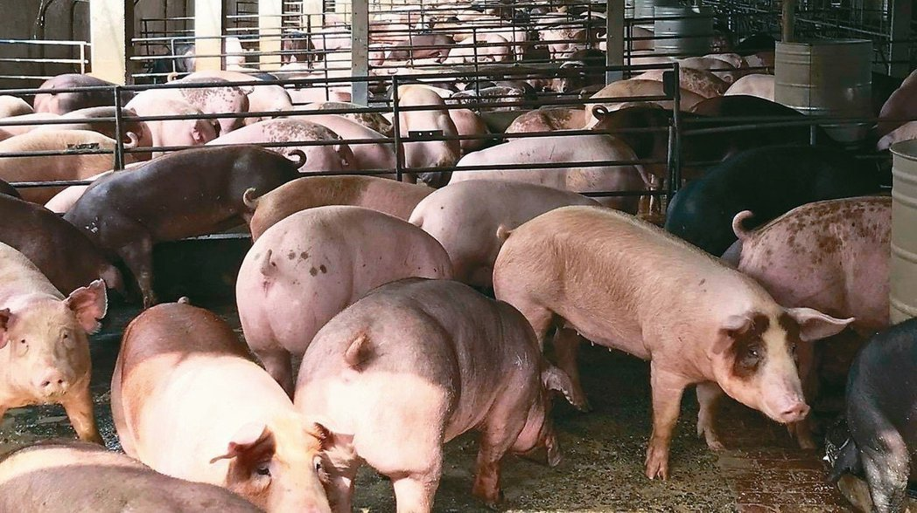

【Word Bank】

coronavirus：名詞，冠狀病毒。
diarrhea：名詞，腹瀉、下痢。
vomit：動詞，嘔吐；名詞，嘔吐物。

取自《自由時報》
http://iservice.ltn.com.tw/Service/english/english.php?engno=1190920&day=2018-04-09

