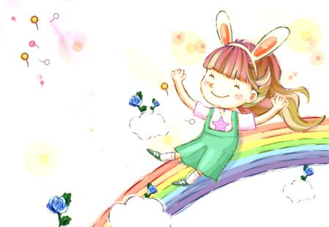
Living Life, Fighting Cancer
勇敢抗癌的鬥士

Suleika Jaouad is a 23-year-old girl from the United States. She’s an online writer who studies women’s rights. Last year, doctors gave Suleika some bad news. They told her that she had cancer.
No matter how old you are, cancer is terrible. However, Suleika is only 23. People rarely get cancer at that age. In fact, people with her type of cancer are usually over 60 years old.
Suleika ha a blog, called Life, Interrupted. It describes the experiences of going up against cancer when you’re still young.

On her blog, Suleika discusses many issues. One is planning for the future while trying to survive the present. Most young people think about jobs and falling in love. It’s hard to do that when you’re having blood tests in the hospital.

Suleika also talks about facing adult problems while she’s still young. On one hand, she depends on her parents for many things. On the other hand, the stress of cancer has forced her to grow up very fast.
The main message of Suleika’s blog in this: value every day of your life.



Key words
Cancer (n) 癌症 discuss (v) 討論
writer (n) 作家 blood (n) 血
type (n) 類型;種類 adult (adj.) 成人的
interrupt (v) 中斷 stress (n) 壓力

