At 55, ’French spiderman’ keeps climbing world’s skyscraper

55歲「法國蜘蛛人」繼續攀爬全球的摩天大樓

Alain Robert, sometimes known as the "French Spiderman" for climbing skyscrapers worldwide, is still defying gravity at the age of 55.
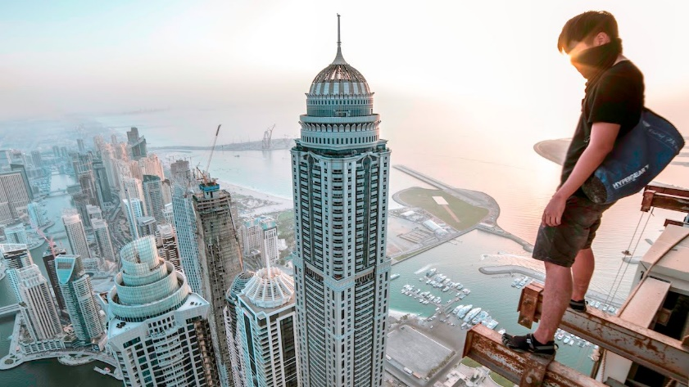
He scaled the summit of the fourth-tallest building in Paris’ modern business district on Wednesday after evading security officers who had thwarted an earlier attempt.
A hobby that started at 11 years old has taken Robert to more than 150 skyscrapers around the world, including Dubai’s Burj Khalifa, the world’s tallest building, the Eiffel Tower, and the Sydney Opera House.

"For me, climbing is a passion, it’s a way of life," he said.
It took Robert just over an hour to scale to the top of the 187-metre high Tour Total.
He has accomplished the feat twice in the past.

He often climbs without permission and has been arrested several times. In 2008, he scaled the New York Times building to unfurl a banner on global warming, and was arrested by police.
Robert sees no end in sight for his vertiginous adventures.
"As long as I have the physical strength to scale heights, I will continue to climb,"he said. （Reuters）

【Word Bank】
defy：動詞，指不服從、公然反抗、蔑視；名詞，指挑戰、對抗。
feat：名詞，指功績、技藝表演、精湛手藝、本領；
形容詞，指合適的、漂亮的。
vertiginous ：形容詞，指令人暈眩的、旋轉的、眼花的、多變的。

取自《自由時報》ttp://iservice.ltn.com.tw/Service/english/english.php?engno=1190360&day=2018-04-07

