Jingle bells:
Japan’s unusual station music
叮噹作響：日本獨特的車站音樂

Minoru Mukaiya, a Japanese composer of "train departure melodies," is one of the world’s most played musicians, with millions of people across Japan listening to his songs every day － but most of them don’t even notice.

Asked how many train jingles he has created, the 61-year-old former keyboard player with the classic band Casiopea pauses. He has lost count and an assistant rushes over with a list.

"170? What? I wrote 170," he says, exploding with laughter. "That can’t be right!"
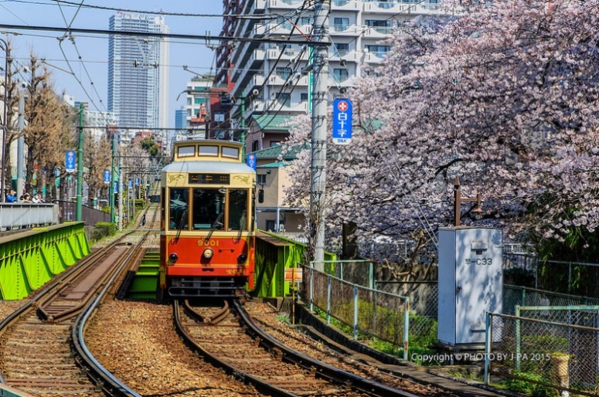

Fans tell Mukaiya the music is "good for their health, for their work, for the mood while walking. It warms them up" on a hard commute to the office.
The songs are capped at seven seconds － the "dwell time" train operators have to cram people into packed commuter trains. Despite the short timeframe, Mukaiya says that each ditty packs in a story.

For instance, in ancient capital Kyoto, the song sounds more respectful of Japanese culture; Osaka station features a soundbite of "I guess I really do love you", one of the region’s most famous songs.

【Word Bank】
jingle：名詞，叮噹聲。
cram：動詞，把…塞進。
ditty：名詞，歌謠。

取自《自由時報》http://iservice.ltn.com.tw/Service/english/english.php?engno=1217810&day=2018-07-19

