China sets amusing rules on Shanghai-Beijing bullet train attendants 服務員該具備的有…
The Middle Kingdom hopes to pair the world's fastest train with the best services
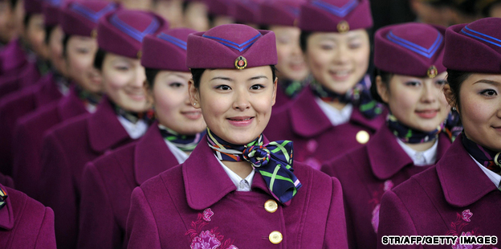
Candidates to work as attendants on the new Shanghai-Beijing bullet trains vie to set themselves apart from the crowd.
With the Shanghai-Beijing bullet train, or Gaotie (高鐵), officially beginning service in two weeks, China is ready to impress the world not only with its speed, but also its on-train services.
To ensure every passenger has the best four hours of their life, bullet train authorities have held a national draft and constructed bizarre training courses by way of selecting the best ladies to serve on the high-speed rail.
Rules for would-be bullet train attendants include:
- Smile with only eight front teeth showing, a feat achieved by daily chopstick-biting training.
- Smile through the eyes. Training for this talent involves covering all facial features save the eyes and smiling to each other.
- The ability to carry out impressive talent shows.
- Provide “5S” service to passengers. Although many indiscreet Chinese jokes can be fashioned out of it, “5S” actually refers to smile, speed, standards, sincerity and satisfy.
A team of newly minted Shanghai-Beijing bullet trains attendants made its public debut in the Hongqiao Railway Station on June 15.
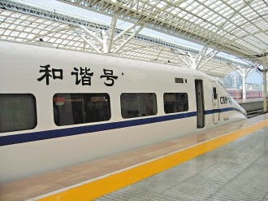
Nicknamed the “high-speed sisters” (高姐) by Chinese netizens, the 313 ladies are between 19 and 22 years old. Each stands above the requisite 165 centimeters tall (five feet, five inches).Train attendants were selected from 3,000 applicants from all over China. Many are former flight attendants.
“Shanghai Railway Bureau has hosted drafts in state-owned colleges in provinces like Shanghai, Jiangsu and Zhejiang since May of last year,” says a supervisor from Shanghai Railway Bureau.
The Shanghai-Beijing bullet train broke world records during test runs, hitting 486.1 kilometers per hour in December 2010. The train is scheduled to make its first official run on July 1. The Shanghai-Beijing high-speed rail trip is estimated to take four hours and 48 minutes.

*Word Bank*
passenger(n.) 乘客 | netizen(n.) net+citizen 泛指一般網際網路使用者
authority(n.) 官方,當局 | applicant(n.) 求職者
bizarre(adj.) 奇異的 | bureau(n.) 局,司,署,處
bullet train attendant 子彈列車服務員 | break world record 打破世界紀錄
debut(n.) 首次登場
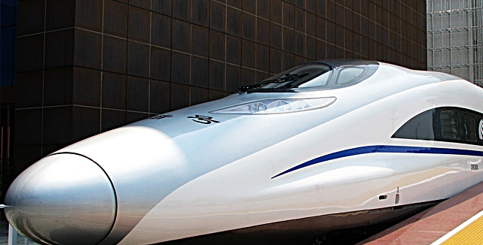
-source by CNN

