Failing your driving test on the first go makes you a better driver

第一次上路考駕照失敗，可以讓你成為更好的駕駛
Did you have a bumpy start as a new driver? Venturing out on the open road, having to deal with impatient drivers honking away … it’s no wonder so many of us fail our driving tests the first time round.
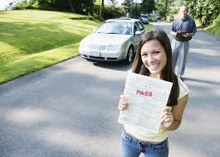
However, the number of times you fail your test could be a positive indicator of your abilities behind the wheel. Car insurance brand Ingenie has assessed how their customers drive by analyzing their speed, acceleration, braking and cornering during a study.

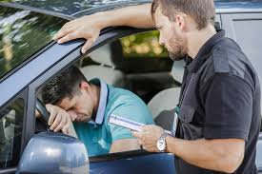
All of these factors accumulate to a score out of 100. On average, drivers who passed their test on their first try earned a score of 78, while drivers who were on their fourth try scored 84. This was the highest average score of the entire study. "Many people claimed to be a better driver and considered it a badge of honor because they passed first time," says Mike Ketteringham, CEO of Ingenie.
"However, our research highlights that the best drivers are those that have overcome failure and benefited from spending more time behind the wheel as a result."

【WORD BANK】
- bumpy：形容詞，顛簸的。
- badge：名詞，象徵。
- behind the wheel：片語，開車；掌舵。
取自《自由時報》http://iservice.ltn.com.tw/Service/english/english.php?engno=1184090&day=2018-03-15

