China’s ban on trash imports causes major confusion
中國禁止進口廢料 引發大混亂

The majority of South Korea’s recyclables are exported to China. Beijing’s recent decision to ban solid waste imports is causing a ripple effect on the recycling programs in Seoul and Gyeonggi Province area.
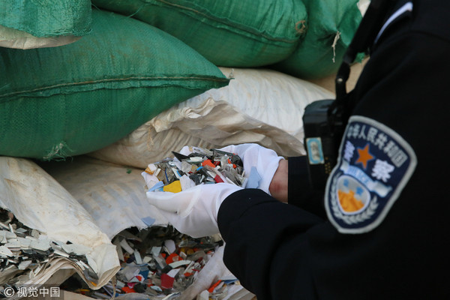
The ban on imports of 24 types of recyclables - a reflection of China’s tougher stance on pollution - mostly impacts local recyclers that used to sell waste to China. Some of the 48 for-profit garbage service companies operating in three metropolitan cities, including Seoul, Gyeonggi and Incheon said last week that they will halt collecting recyclables banned by China starting April 1, citing low margins and increasing processing cost.Such moves immediately caused a stir among residents nationwide who see no other option but to put waste like plastics in authorized garbage bags, which is illegal.
Among the items on the ban list are plastic waste or scraps, waste paper, slag, dross, scalings,and waste textile materials.

WORD BANK
- ripple effect：名詞，連鎖反應、漣漪作用、影響逐漸擴散
- cause a stir：動詞片語，造成（引起一片）混亂、騷（轟）動。
- margin：名詞，邊緣、岸、界線、差價、利潤、賺頭。
- By a wide/narrow margin為片語，指以很大／很小差距。
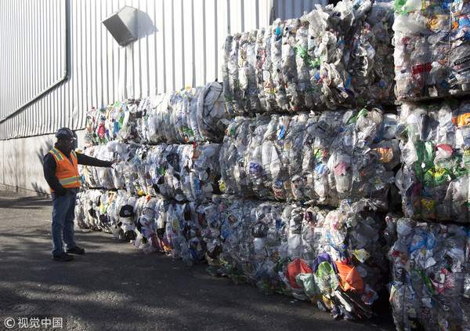

文章來源http://iservice.ltn.com.tw/Service/english/english.php?engno=1190694&day=2018-04-08

