Crayfish staff help Czech brewery keep its water as pure as can be

小龍蝦職員協助捷克釀酒廠維持水潔淨
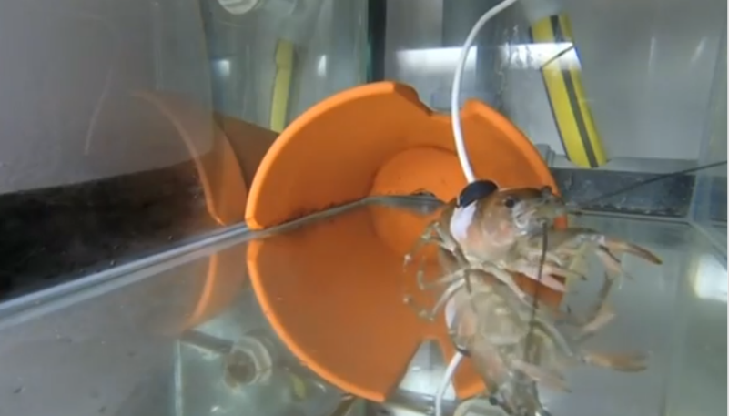

Crayfish equipped with high-tech sensors have been drafted in by a Czech brewery in its quest to keep their water supply pure.

The Protivin brewery in South Bohemia has placed the creatures, which react quickly to changes in their aquatic environment, in fish tanks through which is pumped water from the same natural source that the brewery uses.

The animals are fitted with infrared bio-sensors which monitor their heartbeat and movement. Data is analyzed by a computer, and any changes in the animals’ body or behavior flags a change in the purity levels of the water in its tank.

"When three or more crayfish are moving or change their pulse activity, we know that the water parameters have changed. We can react quickly because we have the result within three minutes," head brewer Michal Voldrich told Reuters.

Scientists use naturally occurring crayfish populations in bodies of water as a method of studying water pollution, effectively turning the animals into bio-sensors.
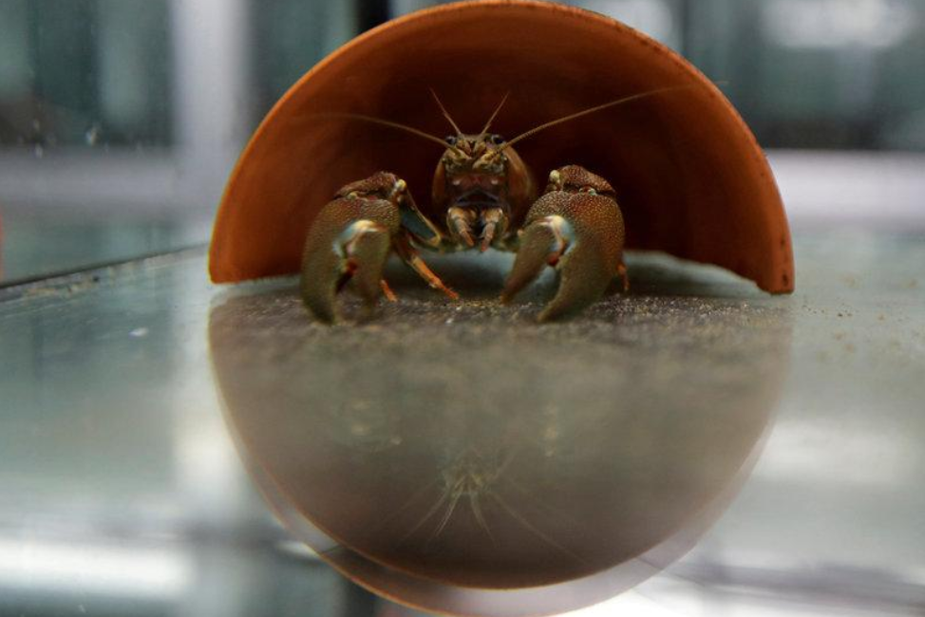

《WORD BANK》
draft in：片語動詞，指徵召。
flag：名詞，指旗幟；動詞，指打旗號示意、做標記、豎旗、興趣衰減；形容詞，指毛髮或動物尾巴垂下的。
turn into：片語動詞，指使變成、進入

文章網址；http://iservice.ltn.com.tw/Service/english/english.php?engno=1139700&day=2017-09-30
圖片網址：https://www.reuters.com/article/us-czech-crayfish-water-purity/crayfish-staff-help-czech-brewery-keep-its-water-as-pure-as-can-be-idUSKCN1C22GP

