India gives ’king of sweets’ a geographical tag to end bitter rivalry

印度給了「甜點之王」地理標示標籤終結激烈對抗
India has awarded a "geographical indications" tag to rosogolla, the king of Indian sweets, after a years-long battle between two neighboring states over the ownership rights.
Luscious rosogolla, or sweet cheese balls dripping with sugar syrup, have long been a favorite dessert across the Indian subcontinent and among the diaspora.

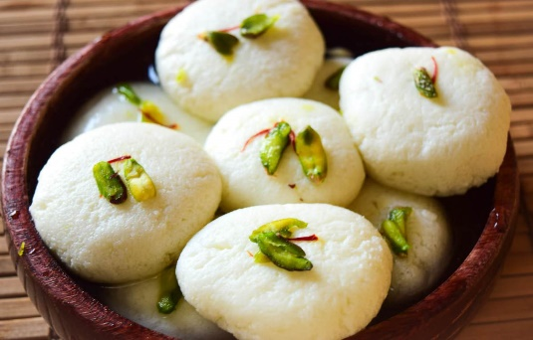
But two eastern states, West Bengal and Odisha, have been arguing over the origins of rosogolla, which means a ball of sweet. They consulted historians and produced old documents to support their claims.
On Tuesday, the federal commerce and industry ministry ruled that the sweet originated from West Bengal, giving it the coveted "geographical indications" tag.
The World Trade Organisation says "geographical indications" defines a good as originating in a particular territory of a member, or a region or locality in that territory, where a given quality, reputation or other characteristic of the good is available.

【WORD BANK】
rivalry：名詞，指競爭、對立。
luscious：形容詞，指甜美膩人的、滿足感官的。
drip：動詞，指滴下、充滿；名詞，指滴答聲、水滴。

取自《自由時報》: http://iservice.ltn.com.tw/Service/english/english.php?
engno=1152912&day=2017-11-18

