Foods That Fight Fatigue
抗疲倦食物
Your pile of homework is growing, but your head is starting to nod. How do you boost your energy to help you focus? Try eating the right foods!
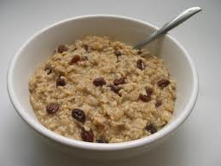
Oatmeal Vitamin B in oats helps produce energy, so a natural oatmeal breakfast will allow you to hit the ground running.
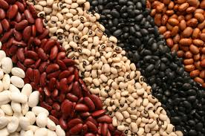
Beans Black beans, soybeans, and kidney beans are truly magic. They are rich in iron, which helps produce energy and increase oxygen levels to make you feel lively. Try a mixed bean salad or bean soup for a tasty energy-giving meal.

Spinach This vegetable is another great source of iron, so it will also keep fatigue at bay. Even better, it can be included in many different kinds of dishes, so you won’t get tired of it quickly.

Yogurt Because yogurt is so soft, it makes it easier to digest, so you’ll get energy from it more quickly than form solid foods. In addition, yogurt is packed with protein, which is a long-lasting source of energy.
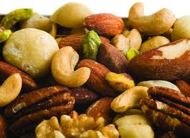
Nuts and Seeds They’re packed with protein and omega-3 fats. These healthy fats provide slow-burning fuel and improve your mood. Keep a package of pumpkin seeds, sunflower seeds, walnuts, or almonds on hand.
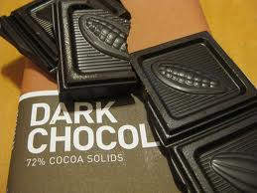
Dark chocolate This is a delicious pick-me-up. Scientists suggest antioxidants in dark chocolate increase levels of a happiness-boosting chemical. Feeling better keeps you from feeling tired.
Word Bank
diet(n)(日常)飲食 | oxygen(n)氧氣
spinach(n)菠菜 | solid(adj)固體的
fuel(n)燃料 | mood(n)心情;情緒
pick-me-up(n)指提神食物 | walnut(n)核桃;胡桃
almond(n)杏仁 | chemical(n)化學物質
hit the ground running立即投入(新活動)

