Taiwan’s Most Generous Person: Chen Shu-chu
台灣之最—慈善家陳樹菊女士

In 2010, Time Magazine released a list of the world’s 100 most influential people. The list included U.S President Barack Obama, singer Lady Gaga, and businessman Steve Jobs. It also had a vegetable vendor from Taiwan, named Chen Shu-chu.
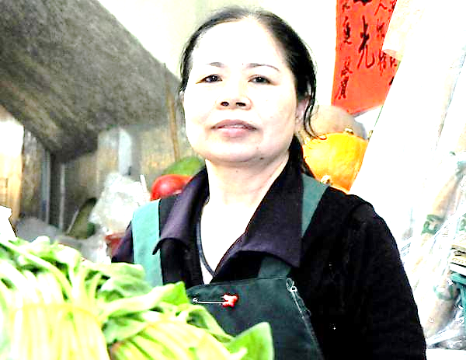
Chen has a vegetable stand in traditional market in Taitung. She sells things like potatoes, onions, and peppers. She works 16 hours every day. So what’s special about her? She’s saved most of her money, and has given more than NT $10,000,000 to charities. Her money has built libraries, improved schools, and given help to poor children.
Chen has saved so much money because she doesn’t care about comfort or luxury. She says that living simply can reduce your budget. Chen mostly worries about two things: looking after her vegetable stand, and helping others.
Chen is very familiar with poverty. She grew up with eight siblings. They all lived on money from the family’s vegetable stand. When Chen was 13, her mother passed away. Chen took over the vegetable stand, and she’s been running it ever since.
Chen hopes that her actions will set an example for all of us. One person has said that Cehn is like a gardener, planting the seed of generosity in the souls of others.
Many companies have offered Chen advertising deals, but she’s turned them all down. She says that if people want to support her, they can buy her vegetables. She still lives a normal life, and spends very little money. She once said that money only useful “when it is used for those who need it.”



Key words
release (v) 發表 pepper (n) 辣椒
president (n) 總統 library (n) 圖書館
potato (n) 馬鈴薯 comfort (n) 安逸;舒適
poverty (n) 貧窮 plant (v) 種植
seed (n) 種子 soul (n) 心靈;靈魂
deal (n) 交易 normal (adj.) 正常的

