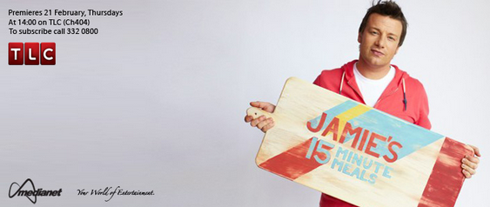

Jamie’s 15 Minutes Meals
奧利佛15分鐘上菜

Jamie Oliver is a celebrity chef whose popularity seems to keep on growing. Having started with a successful series in 1998 after being discovered by the BBC, Oliver went on to become a successful television show host, cookbook author and restaurateur. More than a decade later, Oliver has a new hit show called Jamie’s 15 Minute Meals.
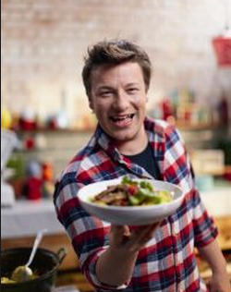
Cutting the time in half from his previous show Jamie’s 30 Minute Meals, Oliver shows viewers how delicious, nutritious, and low-calorie meals can be created in just 15 minutes. His hope is to transform the way people have viewed cooking in the past. By giving cooking shortcuts and tips, along with plenty of other cooking advice, he creates two meals per 30-minute show. It’s not some sort of camera gimmick, though. All of the footage is of him cooking in real time.
The dishes Oliver presents during his show are meant as family meals. He understands that in today’s world, time is of the essence. Most people simply don’t have enough spare time to cook difficult recipes, and they therefore fall into the trap of eating processed foods that are low in nutrition but high in calories. Using mostly fresh, store-bought ingredients, Oliver shows that cooking amazing meals for the entire family can be done in a very short amount of time.
Word Bank
celebrity (n.) 名人,名氣 | calorie (n.) 卡路里
popularity (n.) 受歡迎,流行 | shortcut (n.) 快捷的辦法,捷徑
cookbook (n.) 烹飪書,食譜 | gimmick (n.) 詭計,花招
restaurateur (n.) 餐館老闆 | footage (n.) 影片片段
viewer (n.) 電視觀眾,觀賞者 | be of the essence 至關重要的
nutritious (adj.) 有營養的 | store-bought(adj.) 現成的,商店買來的
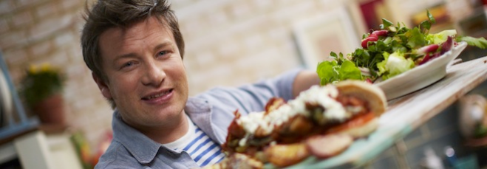
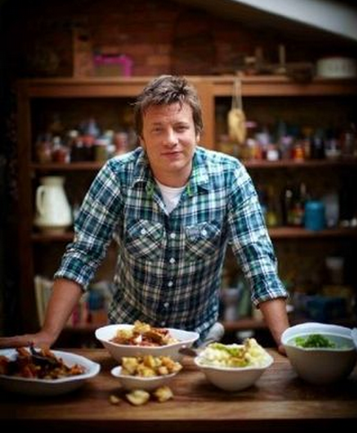
Reference: All Plus Interactive English Magazine

