A company has created scentless fragrances that smell different on each wearer

一家公司創造無味香水 使用者各有不同味道
On the face of it, scentless perfume might seem pointless if it’s not going to spritz you with enticing-smelling scent.
And yet one perfume company is selling just that - Escentric Molecules fragrances are practically scentless, but apparently mingle with the wearer’s natural pheromones to create a unique smell.
It’s a scientific new approach to perfumes - some of the ingredients in the formula are to enhance this aroma-molecule and amplify its key qualities.
The concept was created in 2006 by perfumer Geza Schoen, who has been heralded as a rising star in the fragrance industry.
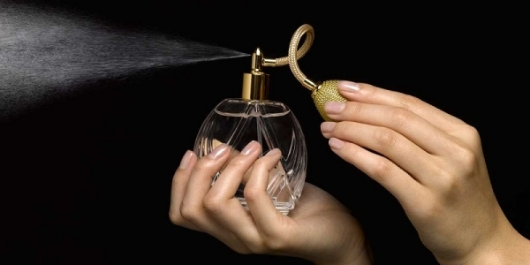
It’s a unique departure from traditional perfumes that are generally made up of top-, middle- and base-notes, and tend to smell the same on everyone.
Celebrities including Rihanna, Beyoncé, Jay-Z and Kate Moss are rumored to be fans. It likely won’t be long before other perfumers are experimenting with the technology too.
The perfume is unisex, but much like the majority of designer perfumes, its price will set you back.
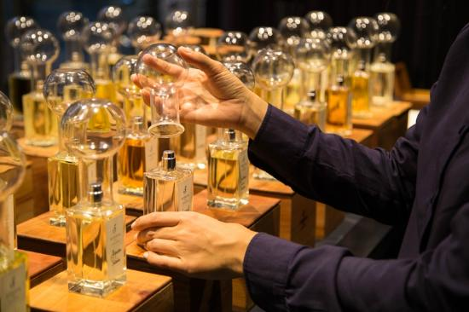

【WORD BANK】
- mingle：動詞，混合；往來。
- unisex：形容詞，中性的。
- set somebody back：慣用片語，讓（某人）破費。

文章來源：http://news.ltn.com.tw/news/world/paper/1088224

