5G: The Coming Key to Technology’s Future
未來科技的關鍵：5G

Lightning-fast processing speeds once considered pipe dreams are now on the horizon.

"This technology is going to offer new types of services that were not possible before, but also reduces the cost," Matt Grob, executive vice president of technology for Qualcomm Technologies, said during a 5G-focused panel discussion at CES. "The demand is really clear."

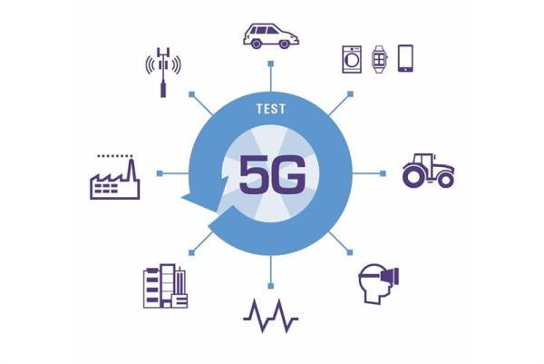
5G － the fifth generation of wireless connectivity － will, at a basic level, allow consumers to download things significantly faster on compatible devices.

When 4G rolled out in 2009, it allowed consumers to download at a speed of about 100 megabits per second. In other words, a person would be able to download the two-hour-long movie "Guardians of the Galaxy" in about six minutes, according to the Consumer Technology Association

"This kind of ’fiber experience in your pocket’ is not a bad way to describe it. But it’s also so much more," said Erik Ekudden, head of technology and architecture at Ericsson. "Any system that we’ll be talking about here (CES), any industrial system, could really benefit from this."

【Word Bank】
5G：專有名詞縮寫，第五代行動通訊系統。
device：名詞，裝置、設備。
wireless：形容詞，無線的。

取自自由時報
http://iservice.ltn.com.tw/Service/english/english.php?engno=1179244&day=2018-02-26

