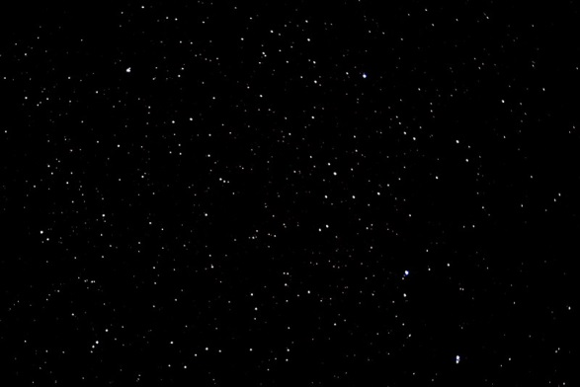
Astronaut Peggy Whitson returns to Earth after record breaking space mission

太空人佩吉．懷特森

創下太空任務新紀錄，重返地球

Following a record breaking space mission, astronaut Peggy Whitson along with her two fellow astronauts returned to Earth from the International Space Station on September 2. The three astronauts returned home on a Soyuz MS-04 spacecraft which landed in Kazakhstan, Central Asia.

Whitson was in space for an extended 288-day mission where she set a new record of being the first American to spend the most collective amount of time in outer space with an accumulated 665 days under her belt.
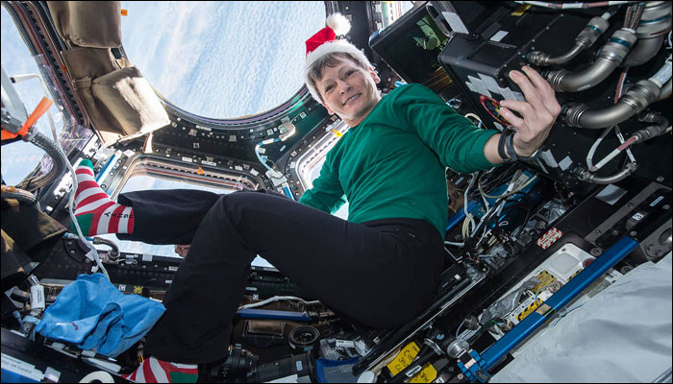

The Soyuz MS-04 spacecraft was undocked from the ISS’s Poisk module at 5:58 p.m. EDT. It took the crew three hours and 24 minutes to enter the Earth’s atmosphere and another three hours to battle Earth’s atmosphere and reach the ground.

In an exclusive interview with the NASA, Whitson shares her feelings about her stay at the ISS. She revealed that what is more important than records is the progress scientists are making in terms of space exploration. She also shared that she is thinking of mentoring young space enthusiasts with the knowledge she gathered in her journey, with the hope that one day they will do the same and more.

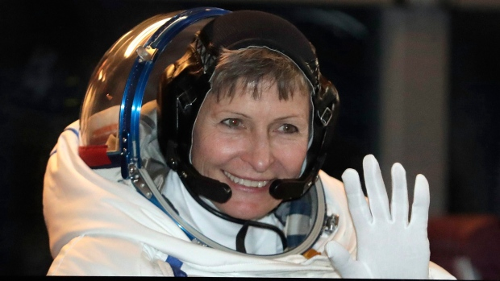

【WORD BANK】
atmosphere：名詞，大氣層、氛圍。
module：名詞，太空艙、模組。
exclusive：形容詞，獨有的、專屬的。

文章網址：http://iservice.ltn.com.tw/Service/english/english.php?engno=1134343&day=2017-09-11
圖片網址：http://zeenews.india.com/space/nasas-record-breaking-astronaut-peggy-whitson-to-extend-mission-at-space-station-1993393.html

