Would you stay in a hotel called 'The Thief'?

想住在賊窩嗎?
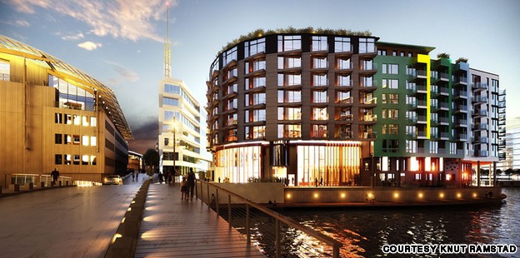
The Thief makes the most of a bad reputation.
In the eighteenth century, the tiny island of Tjuvholmen was where Norway’s most dangerous criminals were exiled and executed.
Now, the area is Oslo’s hottest district for art and architecture.
The latest addition to the Scandinavian cultural hub is a cool new boutique hotel named after the area’s sordid history.
Slated to open on January 9, The Thief hotel takes its name from Tjuvholmen’s nickname, “Thief Island.”
A luxury boutique hotel with an arty edge, The Thief staff includes the former director of Norway’s National Museum Sune Nordgren as the hotel’s art curator.
Nordgren handpicked the art in each of the hotel’s 120 rooms and will be borrowing works from the Astrup Fearnley contemporary art museum next door as part of a sponsorship agreement.
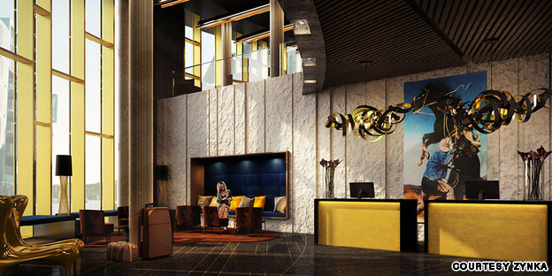The hotel hired the former director of Norway's National Museum as its art curator.
In another nod to its locale’s history, the hotel is participating in a project run by the Oslo Red Cross, selling a series of high profile portraits to raise money for former prisoners who are reentering society.
“Having previous convictions sticks to you,” the hotel’s website says about the project, which is titled “ROM 13.”
“The number 13 has a bad reputation. So did Tjuvholmen. Everyone deserves a new chance. City districts. Unlucky numbers. And people.”
*Word Bank*
hub(n.) (興趣,活動的)中心 | participate(v.) 參與
boutique(n.) 精品店 | reenter(v.) 再進入
sordid(adj.) 可憐的,悲慘的 | conviction(n.) 信念,確信
curator(n.) 館長
-source by CNN

