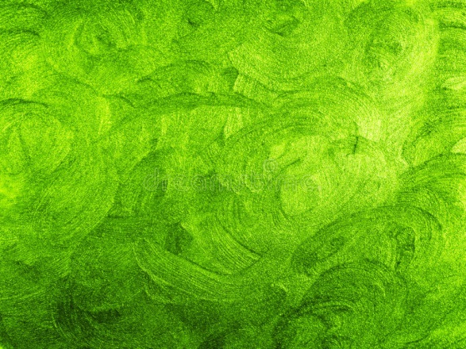
When hoarding gets out of hand and turns a house into trash
當囤積失控到讓房子變成垃圾堆
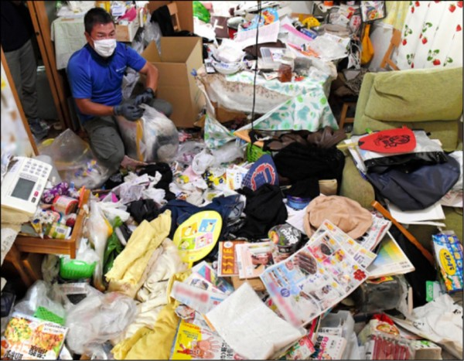
An overpowering stench of raw garbage, cockroaches scuttling up the walls and junk piled high in every nook and cranny：It’s hard to believe that anyone would call it home.
Welcome to a typical "trash house," a term coined for dwellings whose residents seem to have given up on basic norms of hygiene by throwing nothing away.
It is a growing problem for local authorities across Japan faced with clearing out these homes so the occupants can put their lives back together.
Dementia and depression can be factors behind hoarding, but there are also other causes.
The son of a woman in her 80s living alone in Osaka Prefecture got the shock of his life on a rare visit home to find an awful mess inside.
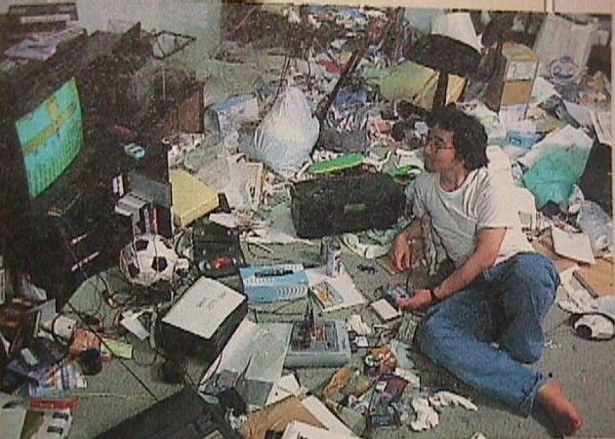
It wasn’t just the smell of garbage, or the flies and the cockroaches. The dining room was piled 30 centimeters high with everything from a carton of eggs to dirty bed linen and a cookbook.

【WORD BANK】
- out of hand：慣用語，失控。
- every nook and cranny：慣用語，到處；所有地方。
- the shock of one’s life：慣用語，形容受到極大驚嚇，大吃一驚。

新聞來源：http://news.ltn.com.tw/news/world/paper/1197643

