World Postcard Exchange
跟世界交換明信片
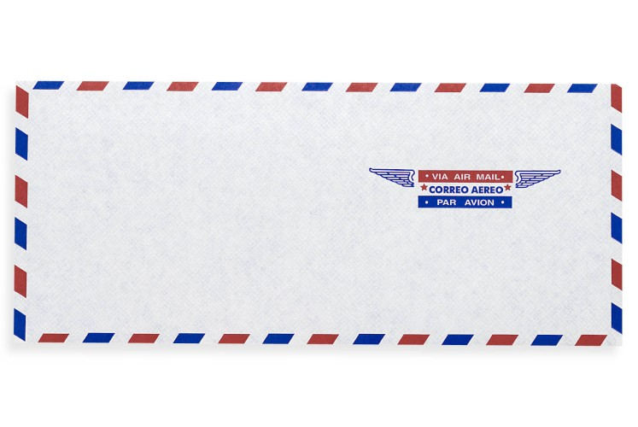
In the modern world of e-mail, texting, and social networking, it seems like the days of opening a mailbox and having letters waiting for you are in the past. Sure, you still get advertisements and bills in the mail, but when was the last time you received a letter from a friend or a postcard? If you’re a postcrosser, however, you might have a postcard from a foreign country awaiting you right now!
Postcrossing is an online project begun by a Portuguese student in 2005. He loved getting postcards and thought that others might enjoy exchanging them, so he devised a Web community for sending and receiving postcards. As it states on the Postcrossing home page, “Send a postcard and receive a postcard back from a random person somewhere in the world!” Now, this little postcard project has around 300,000

members in over 200 countries. Since it started, more than ten million postcards have been received all over the world.
Postcrossing seems to be meeting its goal to “connect people across the world through postcards.” If you want to make opening your mailbox fun again, register and get ready for your mail to become a lot more colorful.
*Word Bank*
text (v.) 發送簡訊 | register (v.) 註冊
await (v.) 等待 | Portuguese (adj.) 葡萄牙的
devise (v.) 策劃;想出 | postcrosser (n.) 參加交換明信片活動的人
connect (v.) 連結 | postcrosser (n.) 參加交換明信片活動的人
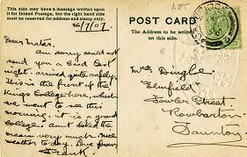
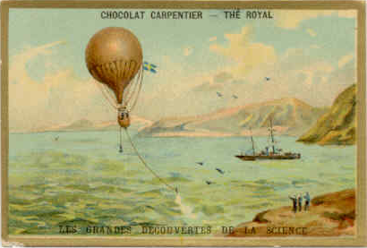
-Michelle Adams

