Dumpling Diplomacy
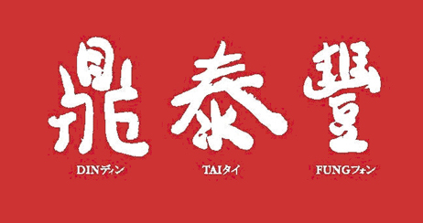
Din Tai Fung Puts Taiwan on the Culinary Map
鼎泰豐的小籠包傳奇
Pauline Chiou, CNN anchor
Let’s talk about some of the unique tastes Taiwan has brought to the world. I’m standing outside of Din Tai Fung restaurant, one of the most popular dumpling restaurants in Taiwan. Its dumpling became an international success pretty much by accident.
In Chinese they called them xiaolongbao, delicate steamed dumplings filled with pork and broth. Taiwanese restaurant chain Din Tai Fung has turned the art of making these little dumplings into the key ingredient for international success. Din Tai Fung never intended to be a restaurant. Forty years ago, owner Chihua Yang’s father originally sold vegetable oil and started selling dumplings as a way to make extra money. The dumplings became more popular than the oil. Now, there are 71 restaurants across the United States, Asia and Australia.
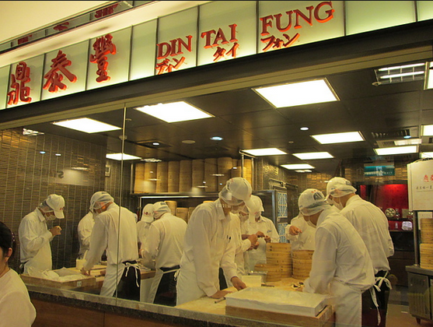
“I think it’s the taste which makes Din Tai Fung different from others,” Yang says. He also credits the chain’s commitment to service with chefs and waiters form Taiwan sent regularly to the other locations. There are so many dumpling and noodle shops is Asia. So what makes this particular chain a runaway success? The customers say consistency. Each restaurant features an open kitchen where you can watch the chefs prepare the trademark dumplings and relatively simple menu that varies little country to country.
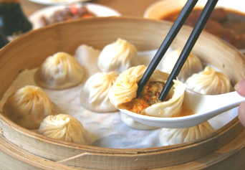
“Of course having a Michelin star is the pride of a brand,” says Yang. “But now we feel much more pressure to make things the best.” The humble dumpling has already proven it can impress the toughest critics, as Din Tai Fung continues to expand beyond its Asian roots.
Word Bank
diplocacy (n.) 外交,外交手腕 | credit (v.) 歸功於,認為有…(優點,功勞)
put…on the map 讓…出名,受矚目 | commitment (n.) 投身,奉獻
culinary (adj.) 烹飪的,食物的 | runaway (adj.) 迅速發展的,遙遙領先的
unique (adj.) 獨特的 | consistency (n.) 一致性,連貫性
delicate (adj.) 精巧的,細緻的 | feature (v.) 以…為特色
broth (n.) 肉汁,高湯 | trademark (n.) 商標,特徵
ingredient (n.) 原料,食材 | humble (adj.) 無特別之處的,不大的
impress (v.) 使佩服,使有好感 | critic (n.) 批評家,評論家
Reference: CNN Interactive English Magazine

