Innovative Package Design
創新包裝讓商品更吸睛
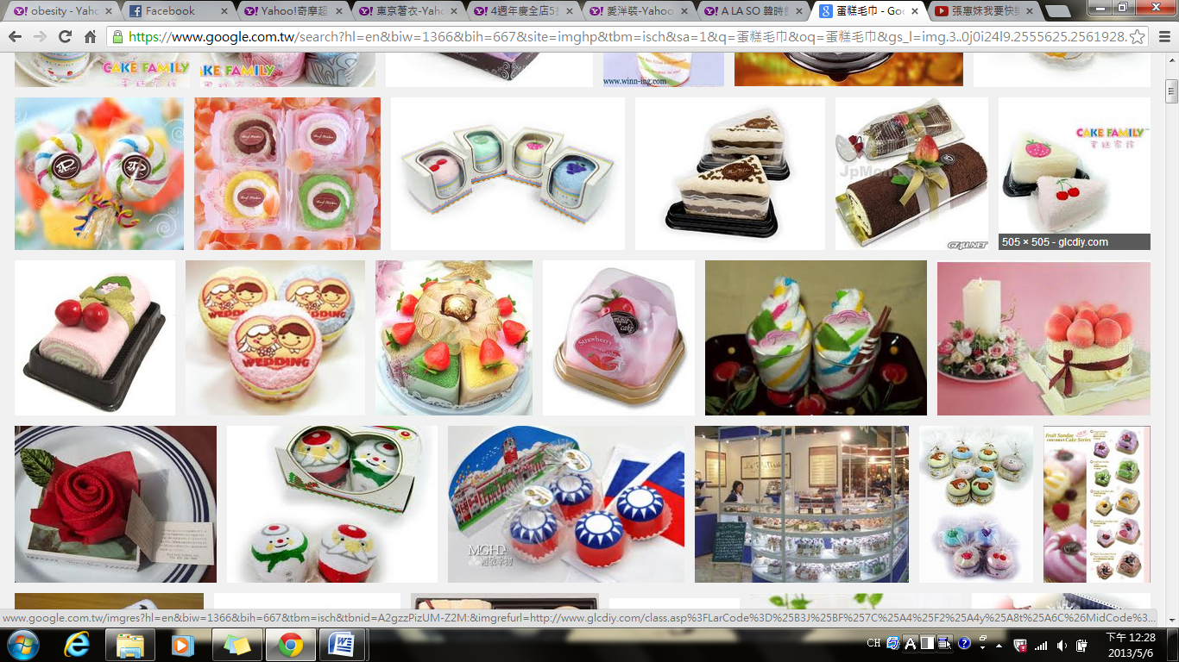
Despite all of our advances and our vast spectrum of knowledge, the human race will never escape one simple fact: we are visual learners. We take in most of what we know with our eyes. This fact is strikingly apparent when we’re shopping, and savvy marketers have many ways to make their products more appealing to our eyes.
When we buy a product, we are also buying the packaging that surrounds it. This packaging has to be eye-catching for customers to see it. In effect, the packaging is the advertising for the product it contains. However, the packaging also must be functional, and whenever possible, it should reflect the best traits of the brand it is trying to promote.
A company that manufacturers towels here in Taiwan takes packaging to a new level of distinction. Rather than just make the towels look like what they are, the company folds the different-colored towels into triangular shapes so they look like nice slices of cake. Other designs of the towels are ice-cream cones and lollipops. The company also has festival-themed towel packages, from boxes of moon cakes and glutinous rice triangles to carnation-shaped towels for Mother’s Day.
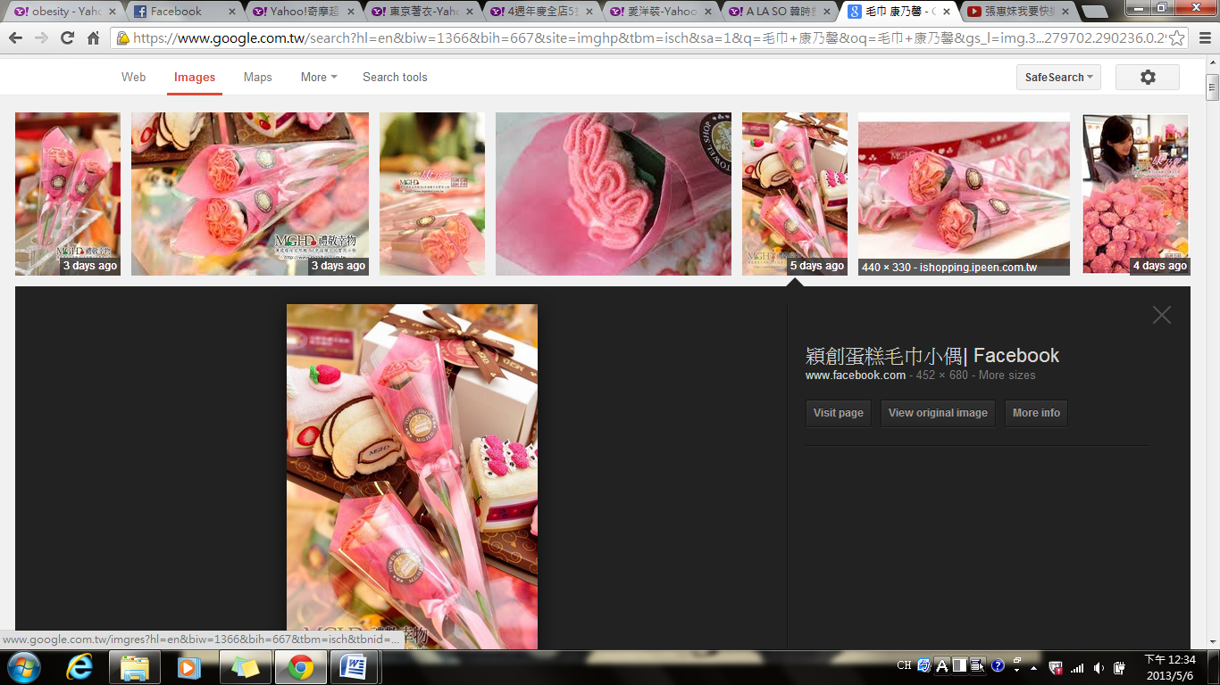
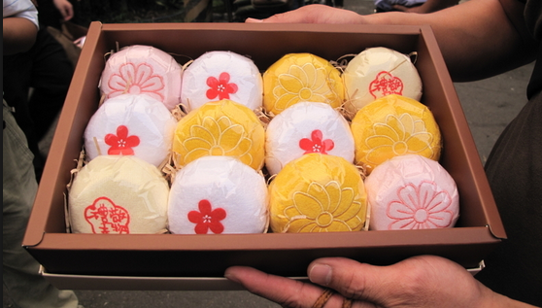
Companies that are aiming to rake in cash by all means put a lot of thought into their product packaging. If they fail to do this, people will just pass by without making the jump from prospect to customer.
“引人注目”的英文怎麼說
形容詞 | 1. appealing
形容詞 | 2. attractive
形容詞 | 3. eye-catching
形容詞 | 4. striking
動詞片語 | 1. attract/catch/get sb’s attention/eye
動詞片語 | 2. become the center of attention
動詞片語 | 3. draw sb’s attention
**Word Bank**
innovative (adj.)創新的
vast (adj.) 浩瀚,廣大的,巨大的
spectrum (n.)範圍,光譜
savvy (adj.)精明的,有見識的
advertising (n.)廣告
functional (adj.)具有功能性的,運轉正常的
trait (n.)特點,特徵
manufacturer (n.)製造商
distinction (n.)傑出,特點,區別
triangular (adj.) 三角形的
glutinous rice (n.)糯米
by all means (ph.)一定,當然
prospect (n.)可能的買家,前景

Reference: All Plus Interactive English

