The Art of the Power Lunch
商業午餐V.S.天價生意
A business lunch in this city can do serious damage to your diet and your wallet. After all, New York is the home of the power lunch. The very name says it all: powerful people, major decisions, and big expenses. Yet, as the economy cratered and landscape quickly changed, companies cut back on corporate cards. 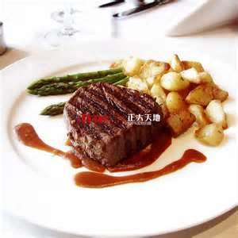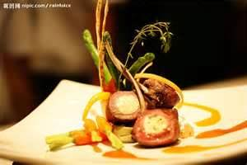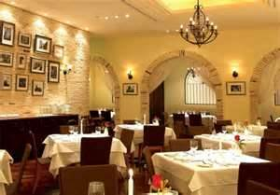
A hundred dollars for lunch is no big deal if you’re trying to make a million-dollar deal. If you go to the Four Seasons, you’re likely to be making a billion-dollar deal. Lunch there is like going through a bunch of front pages of Time magazine. If you’re going to the Four Seasons, you’re not worried about the bill. If you have to think about the cost, you shouldn’t be there.
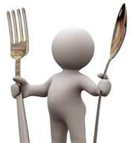
“Power lunch” was basically coined at the Four Season Restaurant in the 1980s and ever since then we never stopped. When you take somebody out, you’re entertaining them. This is about breaking bread. It’s about enjoying life. It’s not just spending money.
Affordable fixed-price menus aim squarely at the businessman and are now popping up across New York. It’s a trend when Michelin star restaurants like Jean-Georges are leading the way. So, if you’re meeting somebody who is the next big deal, forget about the price.
*WORD BANK*
landscape | (n.)環境;風貌
coin | (v.)創造;鑄造
entertain | (v.)娛樂
break bread | (ph.)與人共餐
affordable | (adj.)買得起的;價格經濟實惠的
pop up | (ph.)竄起

