Cambridge University set to scrap written exams because students’ handwriting is so bad

劍橋大學考慮廢除紙筆考試，因為學生字跡難以辨識
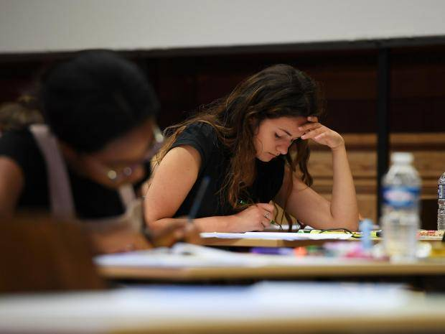

Cambridge University is seeking to scrap exams written with a pen and paper due to the deterioration of students’ handwriting. Examiners find it harder and harder to read internet generation’s scripts.

A growing reliance on laptops has led to students’ writing becoming increasingly illegible. The problem has become so bad the university is preparing to switch to examinations on laptops – ending 800 years of handwritten exams.

Dr. Sarah Pearsall, a lecturer at the university’s history department, told The Telegraph：“As a faculty we have been concerned for years about the declining handwriting problem. There has definitely been a downward trend.’

She said students still wrote by hand several hours daily 15 or 20 years ago, but now mostly do not do that except during exams. When examiners could not read scripts, a growing number of students had to return to university during the summer period to read their answers aloud to administrators.
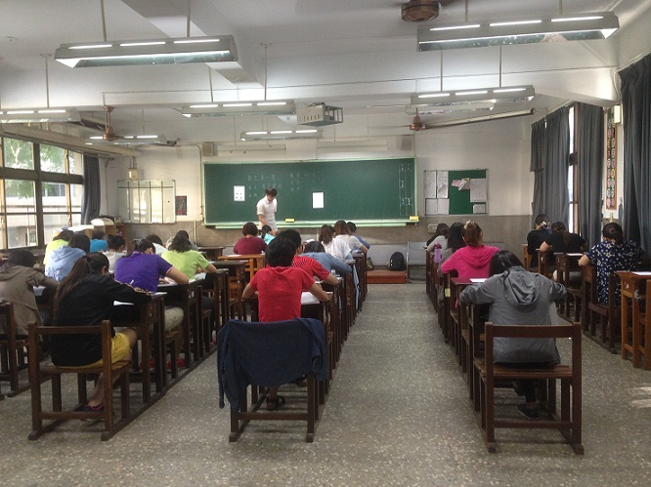

【WORD BANK】
scrap：動詞，扔棄，廢除。
examiner：名詞，考官，主考者。
illegible：形容詞，難以辨認的，字跡模糊的。

文章網址：http://iservice.ltn.com.tw/Service/english/english.php?engno=1134582&day=2017-09-12
圖片網址：http://www.independent.co.uk/news/education/education-news/cambridge-university-scrap-bad-handwriting-exams-sarah-pearsall-a7938131.html

