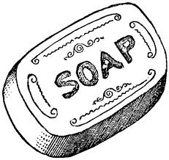
A VERY ATTRACTIVE SOAP
磁性肥皂問世
When you have something sticky on your hands, a little soap helps clean the mess right off. Then, soap and dirt are washed down the drain. Scientists at Bristol University aren’t satisfied with a soap that’s washed away, though. They’ve created one that can be collected with a magnet.

By dissolving iron into soap materials, the scientists ended up with soap particles that had tiny metal centers. With the use of a magnet, the soap could be made to move where the scientists wanted it to go. The potential applications for this kind of soap are very exciting. Imagine an oil spill in the ocean. Most current oil spill cleaning agents have their own harmful effect on the environment because they can’t be removed easily after their cleaning job is over. However, oil-trapping magnetic soap could be attracted to one location with a magnet and scooped out of the ocean.
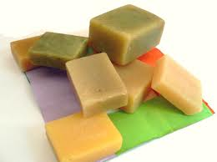

While scientists are still a long way from producing this soap commercially, they have shown that it can be made. One day, it may become part of what helps us clean up our planet.

*Word Bank*
magnet(n.) 磁鐵 | application(n.) 應用
dissolve(v.) 分解,溶解 | spill(n.) 溢出,濺出的液體
particle(n.) 分子,微粒 | oil-trapping(adj). 堵住、收集油汙的
potential(adj.) 可能的,潛在的 | scoope(v.) 舀出,挖出

