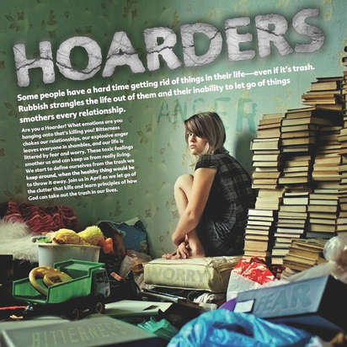
Controlling the Urge to Hoard
清爽過生活 向囤積癖說Bye-bye!
For the worst hoarders, professional therapy may be necessary to get them to part with all their old junk. It can take up to a year of seeing a psychiatrist before they start throwing things out. For the rest of us, though, there are some simple steps we can follow.
First of all, don’t rush in and start throwing things out left and right. This may lead to strong feelings of regret later on, and you might accidentally throw out something you really do need. Schedule a short amount of time for cleaning out your home each day, an hour at most, and work consistently until you’re done.
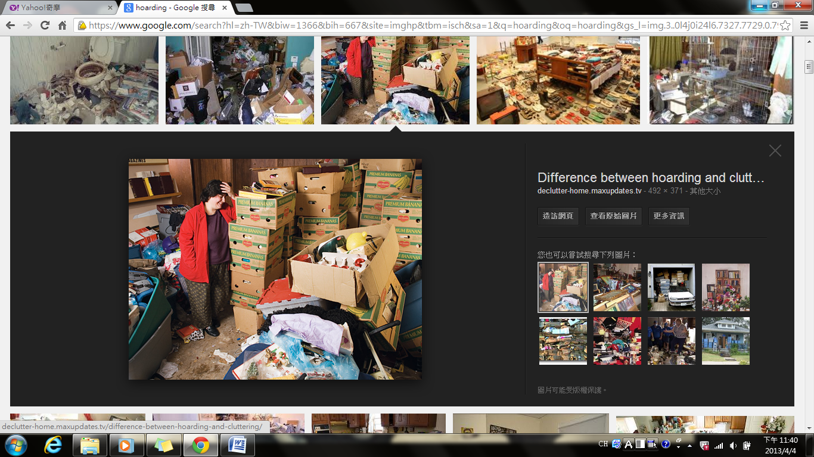
As you make progress, resist the temptation to put things aside. Handle a thing once and make a firm decision about whether each item stays or goes. If you have collections of things like books from your childhood, keep a few cherished ones and give the rest to a local charity. Put what you keep in boxes for safe, convenient storage that doesn’t mess up your living space, and throw out or recycle what you can’t give away.
An uncluttered home is the best way to clear your mind and free yourself from the trap of having too much stuff. If you’re a hoarder, pick a room and start cleaning up your life today.

word bank
hoard (v.) (非必要的)囤積 | consistently (adv.) 持續地,一貫地
professional (adj.) 專業的,職業的 | temptation (n.) 引誘,誘惑物
therapy (n.) 療法,治療 | cherish (v.) 珍愛,珍惜
left and right 不加選擇地;到處 | storage (n.) 儲藏,保管
accidentally (adv.) 意外地;無意間 | psychiatrist (n.) 精神科醫生

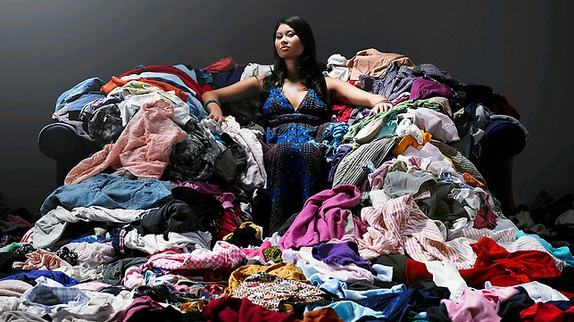
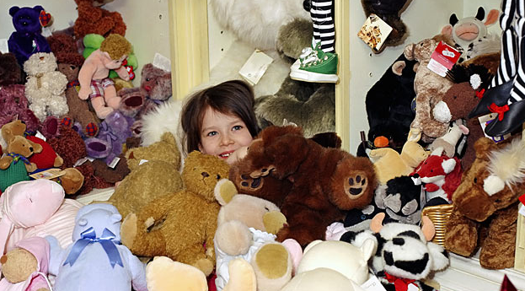
Reference: All Plus Interactive English

