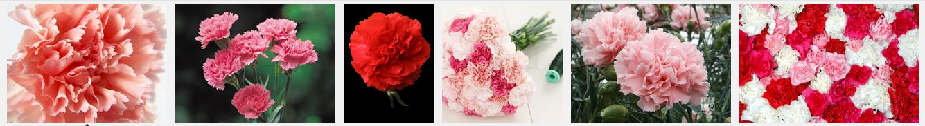
Carnations: More Than Just Pretty Flowers
你所不知道的康乃馨
Giving mothers a carnation on Mother’s Day is a tradition, and these pretty flowers are very popular for other occasions as well. Yet carnations can be used for many other things, and in the past, they were more than just decorations pinned to lapels. In fact, they were sometimes served on plates and eaten.
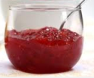
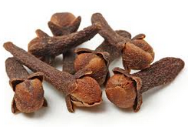
The petals of carnations are edible and have a clove-like taste when eaten. They can spice up dishes or add beauty to plates of food as decorations. In the Middle Ages, carnations served as an inexpensive substitute for cloves. They were used to make spiced beer, wine, and vinegar. In addition, they were mixed into herb butter and jellies.
Carnations were also thought to have medicinal purposes. People would eat them to help cure kidney ailments, and they believed carnations also had the ability to calm people and reduce nervousness. The petals would also be combined with creams, which would then be put on the skin to help cure skin afflictions.
The flowers people now wear are all hybrids of the original flowers, any they actually are cultivated for their beauty rather than any other purpose. Once loved for many other reasons, carnations certainly have more to them than meets the eye.
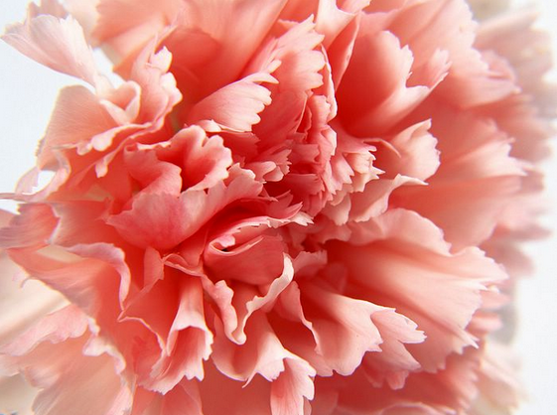
**Word Bank**
carnation (n.)康乃馨
lapel (n.)西裝上的翻領
edible (adj.)可食用的
clove (n.)丁香
spice up sth(ph)調味
substitute (n.)代替的人或物
vinegar (n.)醋
herb (n.)香草植物,藥草
medicinal (adj.)藥用的,有療效的
hybrid (n.)混種,混合物
cultivate (v.)栽培作物,培養
more to sth/sb than meets the eye(ph)不容小覷

疾病,病痛的各種英文說法
illness 泛指疾病,病痛
sickness泛指疾病,病痛; 也有噁心,想吐的意思, 如motion sickness暈動症
disease 主要用於政是醫學名稱疾病, 如Alzhimer’s disease阿茲海默症
ailment 指較輕微的病痛,常用於身體部位病症, 如back ailment背痛
affliction 指疾病長期以來所造成的痛苦
Reference: All Plus Interactive English

