Scientists create DNA-like molecule to aid search for alien life

科學家創造「類DNA」分子，協助搜尋外星生命

Dubbed "hachimoji" DNA, a team of US based research ers, have tested their ‘alien’ DNA and discovered that it not only reproduced the molecular recognition behavior of standard 4-letter DNA but it also met the Schrodinger requirements for a Darwinian system of molecular evolution.
The synthetic hachimoji includes the four G, A, T and C nucleotides but also four others that mimic the structures of the informational ingredients found in regular DNA.
Although now at double capacity, even more could be packed in this expanded genetic code system so that it might work with larger, more complex molecular structures.

"By carefully analysing the roles of shape, size and structure in hachimoji DNA, this work expands our understanding of the types of molecules that might store information in extraterrestrial life on alien worlds," said Steven Benner a researcher at the Foundation for Applied Molecular Evolution in Alachua, Florida, who worked on the project.
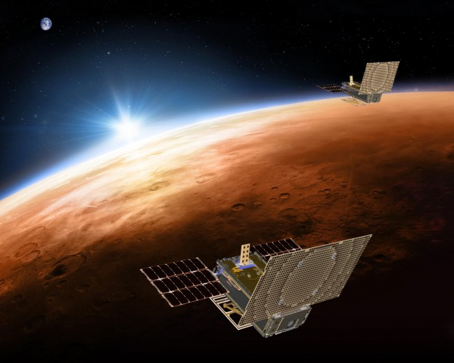

【WORD BANK】
molecule：名詞，分子。
evolution：名詞，演化、進化。
mimic：動詞，模仿、摹擬；名詞，擬態。

文章網址：https://features.ltn.com.tw/english/article/paper/1271462

