New trends in video games
電玩遊戲新潮流
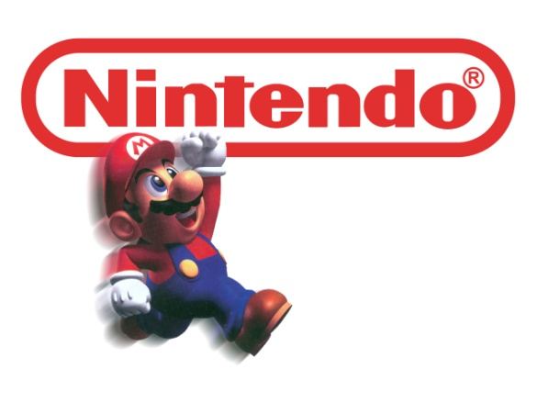
Nintendo of America president Reggie Fils-Aime isn’t worried. Yes, sales of the Wii have tapered off. Yes, analysts doubt that its successor, the game machine/tablet Wii U, will sell as well as the original. Yes, Facebook, mobile, and Xbox Kinect have poached Nintendo’s audience of fitness-minded moms and kids.
But Fils-Aime has faith. “To buy into a console, consumers need a very clear, understandable and persuasive reason,” he explains. “We believe that’s games” If he’s wrong, Nintendo could be in trouble. If he’s right, well, Nintendo may still be in trouble. Building a game console that only plays games in becoming a risky proposition. Wii U will include a controller with a touch-enabled screen, camera and NFC.
The Wii U’s release won’t just determine the fate of one of the most successful gaming companies ever. It will also shed light on whether traditional consoles have a future in an era of multifunction devices.
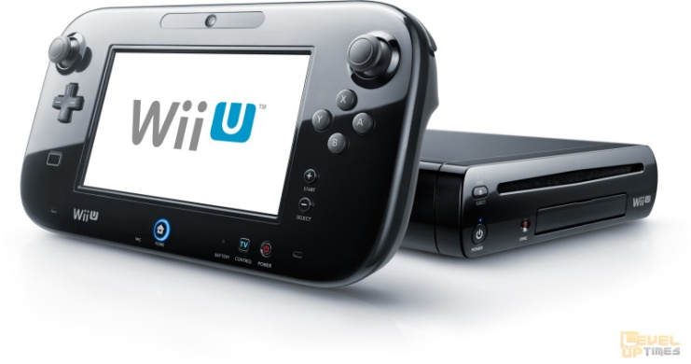
From a cultural standpoint, games have never been bigger. Nielsen found that half of all American households have a console, and the amount of time spent playing games has increased 7 percent since last year.
Blockbusters like Call of Duty still have billion-dollar releases. But games of that scale require years and cost millions to produce. Alex Seropian, a cofounder of Bungee, the studio that created the Xbox mega-franchise Halo, sold his company to Microsoft in 2000. “The $60 console game is going to disappear,” he says. Poised to replace it is an ecosystem teeming with games of all sizes and prices.
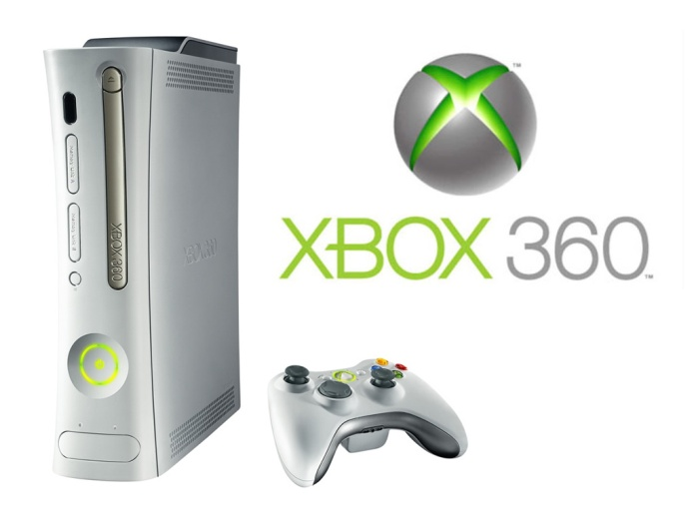
The future of gaming hardware may well come to look like the mobile phone industry: one or two market leaders and a host of smaller competitors. That’s what makes the Wii U a good barometer of the future of the console. We’re about to learn just how much pull Mario still has.

**Word Bank**
poach (v) to take something that belongs to someone else and use it as you own
console (n) a special area containing a set of controls for electric equipment, especially on an aircraft or boat
proposition (n) a suggestion or statement for consideration
controller (n) a gadget that controls something else
NFC (Near Field Communication) a technology that uses radio frequencies to communicate between devices that are in close proximity to each other
shed light on (phr v) to help to explain a situation
mega-franchise (n) an extremely big or highly successful brand or business
teem with (phr v) to contain large numbers of something, especially animals or humans
barometer (n) something that clarifies how a situation is changing or affecting things

Reference: Advanced

