NASA scientists plan to stop supervolcano that could kill millions

NASA科學家計畫阻止可能令數百萬人喪命的超級火山

With around 20 so-called supervolcanoes scattered around the world right now, NASA says that an eruption of just one of them could be a catastrophic threat to the human race.

Hidden under Yellowstone National Park in the US, the Yellowstone Caldera is an enormous crater-like depression and is filled with red-hot magma. If it were to blast in a super-eruption, molten material that it spews out would incinerate everything within 60 miles and leave Wyoming and surrounding states blanketed with three feet of volcanic ash.

The dust and gases released by the eruption would also blot out enough sun to wipe out crops and plunge the world into a ’volcanic winter’ that could last for decades and kill millions.

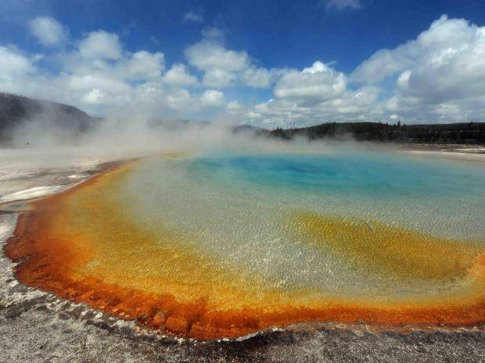
The team says that they could prevent an eruption by siphoning geothermal energy from the caldera and converting it into electricity.

Water would be pumped through the borehole into the hot rock and then return to the surface at a temperature of more than 600 degrees Fahrenheit. This would then be used to drive turbines and generate electric power. When cooled, the water could be pumped back underground to subtract more heat.
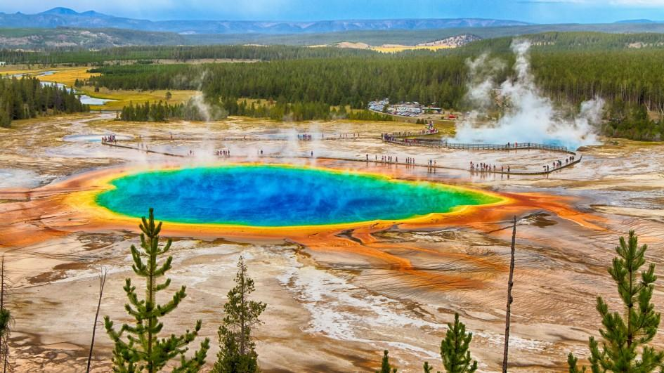

《WORD BANK》
enormous：形容詞，巨大的。
spew：動詞，噴出。
blot out：動詞，遮蔽。

文章網址：http://iservice.ltn.com.tw/Service/english/english.php?engno=1158181&day=2017-12-07
圖片網址：https://kids.nationalgeographic.com/explore/nature/yellowstone/#YELLOWSTONE LAKE.jpg
http://www.independent.co.uk/life-style/gadgets-and-tech/supervolcano-yellowstone-caldera-nasa-scientists-plan-stop-eruption-kill-millions-us-earth-a7934311.html

