Pakistan TV airs first transgender anchor
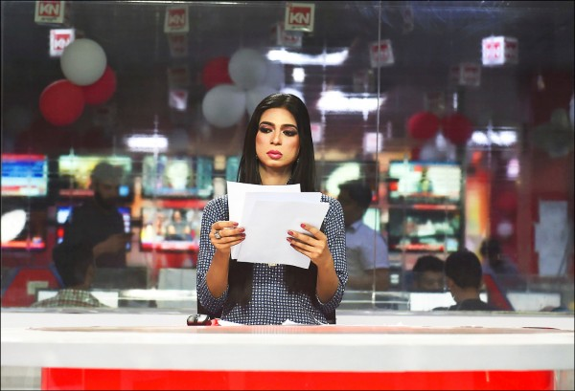
巴基斯坦推出首位跨性別主播
A Pakistani news channel has hired the country’s first transgender TV newsreader. She anchored her first show on Friday, after three months of training.

Marvia Malik, 21, made her debut appearance on the Kohenoor TV news channel. Ms Malik, a journalism graduate who has also worked as a model, told the BBC she was moved to tears when she was offered the job.

She hoped her work would help improve the lives of Pakistan’s transgender community. "Our community should be treated equally and there must not be any gender discrimination. We should be given equal rights and be considered ordinary citizens, instead of third-gender," she said.
Transgender people face severe discrimination in Pakistan and many struggle to find jobs. Some are forced into begging, dancing or prostitution to earn money. Many transgender people, intersex people and eunuchs have been attacked, murdered, and raped in the country, as well as other South Asian nations such as India and Bangladesh.

《WORD BANK》
- newsreader：名詞，新聞播報員，新聞閱讀器。
- intersex：名詞／形容詞，雙性人（的），陰陽人（的）。
- eunuch：名詞，閹人，太監，宦官。

文章來源：http://news.ltn.com.tw/news/world/paper/1189484

