Bra company boss forces male employees to experience E-cup boobs

內衣廠商老闆強迫男性員工親身體驗E罩杯
Ignace is the CEO of PrimaDonna, a bra company based in Belgium. He has forced his male employees to experience what it is like to have E-cup boobs - by hanging weights around the men’s necks.
He believes that the men in his employment can’t design and manufacture the best lingerie if they don’t know what it is like to have such breasts.
Thus, Ignace decided that each male would be given a pair of weights, which would hang around their necks and simulate the experience of having big boobs. He said： "there is only one way for a man to realize what an E-cup feels like... and that is having an E-cup."
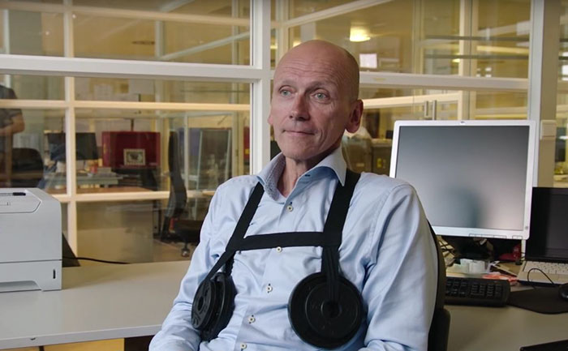
That way, they would understand how important it is to create bras that are functional and comfortable.
It wasn’t long before the men started to complain about sore backs and sore shoulders due to the extra weight they had been carrying around on their chests.
Ignace added: "Good support is important. Everybody at PrimaDonna knows that now."
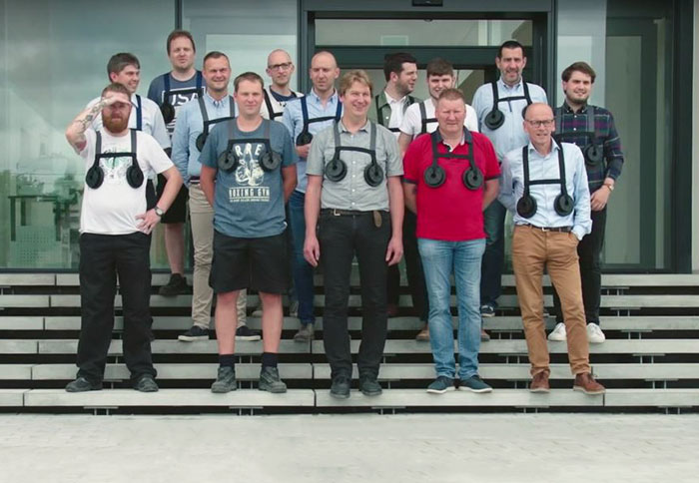
【WORD BANK】
lingerie：名詞，女用內衣。
simulate：動詞，模擬。
sore：形容詞，痠痛的。

文章址網：http://iservice.ltn.com.tw/Service/english/english.php?engno=1090151&day=2017-03-30

