About 440,000 South Koreans prepare for civil service exams
南韓約44萬人準備公務人員考試

About 440,000 people in South Korea are estimated to be preparing to take the state-run civil service exams. The research was conducted by Kim Hyang-duck and Lee Dae-joong, who are in doctoral courses at Konkuk University and Korea Advanced Institute of Science and Technology, respectively.

More than half of the test applicants counted "job security" as the primary motivation for choosing a civil servant as a job, while 48 percent said they study more than 10 hours every day for the exams. Only 2.9 percent of test applicants said they want to be a civil servant "to serve the country."
About 34 percent of test applicants who responded to the survey said they decided to prepare for the exam when they were juniors or seniors at college. The average age people start preparing for the exam is 24.5.

【Work Bank】
respectively：副詞，各自地、分（個）別地。
count：動詞，計算、視為、看作。
大學4個年級的學生：freshman（大一新鮮人）、sophomore（大二生）、junior（大三生）、senior（大四生）。
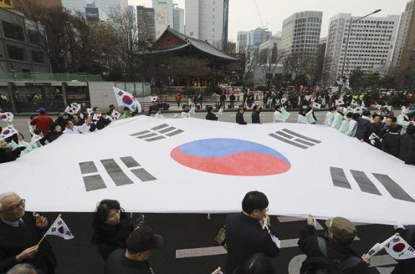

取自自由時報
http://iservice.ltn.com.tw/Service/english/english.php?engno=1192582&day=2018-04-15

