This library loans out ties and handbags so those with limited resources can go to job interviews

這間圖書館出借領帶與手提包 讓資源有限者參加工作面試

For a young person, going to a job interview can be expensive. You need nice clothes and a case or handbag to hold your resume and other documents.
But if you live in New York, there’s help. The New York Public Library is making sure you dress to impress
in all your interviews － as long as you don’t have
any library card fines greater than $15.

The NYPL’s Riverside Library has rolled out a "Grow Up Work Fashion Library," which lends out neckties, handbags and briefcases to responsible patrons.
The goal is to help anyone with limited resources to get clothing and accessories for interviews, graduations and other "business-like occasions."
The idea was born when Michelle Lee, a young adult librarian at the Riverside branch, was helping students prepare for college interviews and part-time jobs.
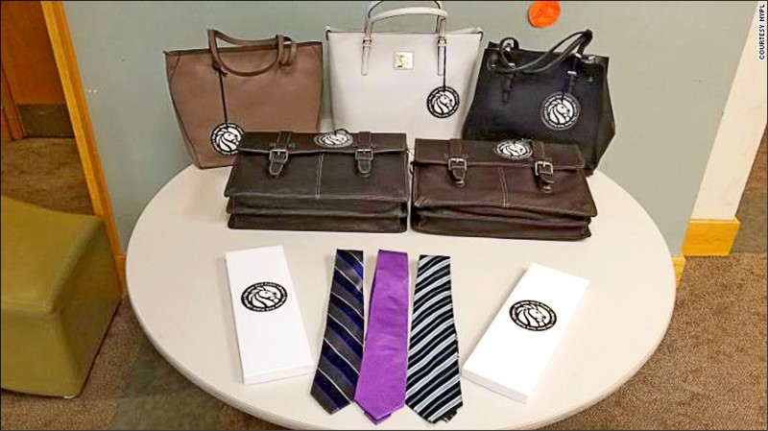

【WORD BANK】
loan（something）out（to one）：慣用語，出借，把東西借給某人。
as long as：慣用語，倘若，只要。
roll out：慣用語，首次提供（產品或服務）。

文章網址：https://features.ltn.com.tw/english/article/paper/1275987

