Britain’s Queen Elizabeth II celebrates 92nd birthday

英國女王伊莉莎白二世慶祝92歲高壽

Queen Elizabeth II, Britain’s longest reigning monarch, celebrated her 92nd birthday on Saturday. To mark the –photos of a young Queen Elizabeth and paid tribute to her lifelong dedication to public service.

The Queen welcomed Commonwealth leaders to Britain this week for a summit at which it was confirmed that her son, Prince Charles, would be the organization’s next leader.
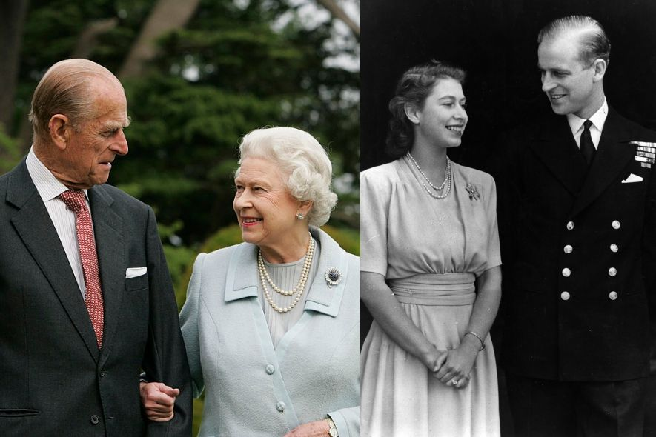

On Sunday, she will start the London Marathon remotely from a special podium in the grounds of Windsor Castle. It will be 110 years after the 1908 Olympic Marathon was started at Windsor Castle by the then Princess Mary, grandmother to the Queen.
Next month, her grandson, Prince Harry, and Meghan Markle will wed at Windsor Castle.
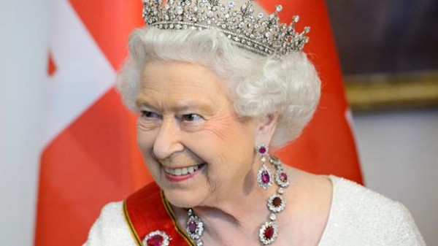

【World Bank】

reign：動詞，在位。

royal：形容詞，皇家的；名詞，王室。

leader：名詞，領袖。

取自《自由時報》http://iservice.ltn.com.tw/Service/english/english.php?engno=1194762&day=2018-04-23

