Underwater Museum
海底博物館
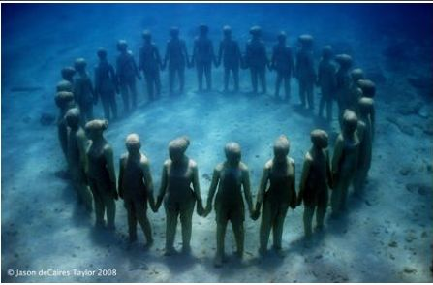
When you think of sculptures, air-conditioned halls with shiny floors might come to mind. You probably don’t expect a school of fish to swim past you as you float by a statue. However, at the Museum of Underwater Art in Mexico, that’s exactly what you can experience.
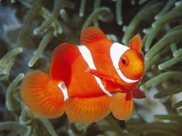
As its name suggests, the Museum of Underwater Art is located underwater in the ocean off the coast of Mexico. A 420-square-meter area of seabed hosts over 400 life-size statues created by British artist Jason deCaires Taylor to show the relationship between art and conservation. Taylor worked with marine biologists to create art that would encourage coral growth and provide homes for endangered sea life. He also hopes that these sculptures will draw tourists away from natural coral reefs and allow the damaged reefs to heal.
Many of the world’s coral reefs are dead or dying, so Taylor’s art is a gift to the oceans. As his statues are slowly covered with new life, they will remind visitors that people are connected to the natural world around them.
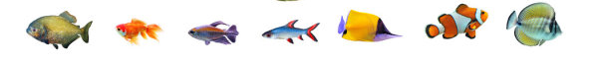
*Word Bank*
sculpture (n.) 雕刻品,雕像 | seabed (n.) 海床
air-condition (v.) 裝有空調設備 | marine (adj.) 海洋的
shiny (adj.) 光亮的 | biologist (n.) 生物學家
heal (v.) 痊癒 | coral reef (n.)珊瑚礁

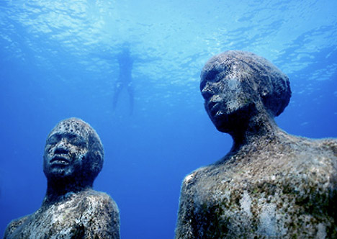
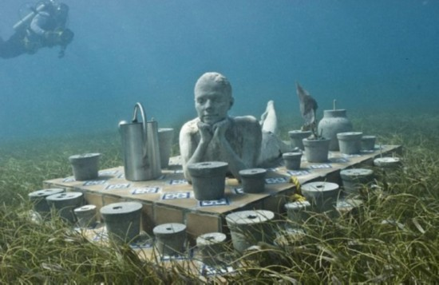
-Michelle Adams

