Montrealers embracing Black Friday, Cyber Monday sales

蒙特婁民眾響應「黑色星期五」

和「網路星期一」特賣

When it comes to Black Friday and Cyber Monday sales, it took some time for Quebec retailers to really start following the lead of their American counterparts. But a new survey shows that more and more Quebecers are embracing the sales that have become the unofficial kickoff to the holiday season.

Market research company L’Observateur surveyed 950 Quebec consumers in the first week of November to find out just how popular the shopping trend has gotten in the province.

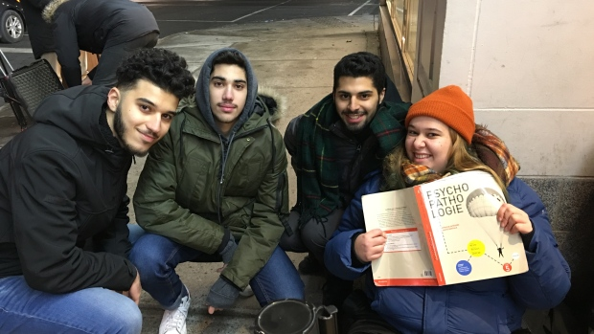

Michelle Rivard, president of the firm, says the percentage of Quebecers who take advantage of Black Friday and Cyber Monday sales has jumped by 20 per cent over last year. "What we found this year is that consumers tell us that they will spend approximately $342 on average, which makes $946 million of spending that will occur from today until next Monday."
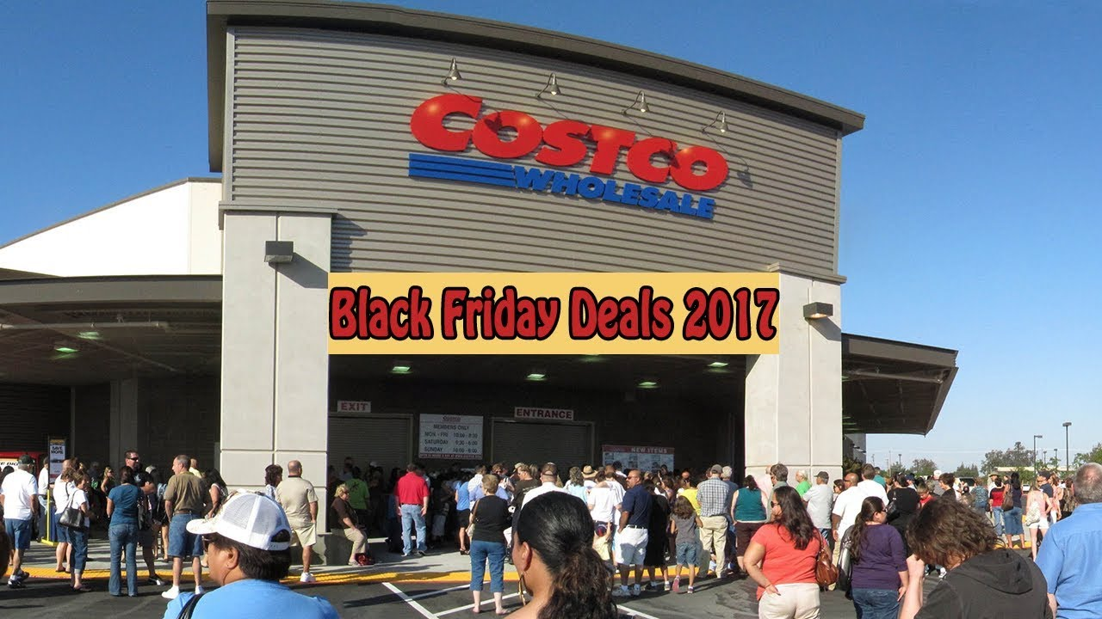

新聞辭典
Black Friday：名詞，黑色星期五。
Cyber Monday：名詞，網路星期一。
holiday season：名詞，假日季節。

文章網址：http://iservice.ltn.com.tw/Service/english/english.php?engno=1155349&day=2017-11-27
圖片網址：https://www.youtube.com/watch?v=CTFVCFXHK0Q

