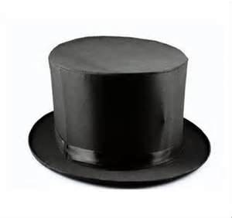
Magician Copperfield Dazzles Robbers
魔術師大衛考柏菲遇搶 巧施小技唬弄劫匪

Professional magician David Copperfield found a real-life application for his magical tradecraft recently. While his display of hocus-pocus flair would surely be the envy of fictional boy wizard Harry Potter, it was muggers not Muggles dazzled by the sleight-of-hand maestro April 26.
The incident occurred following a performance by Copperfield in West Palm Beach, Florida.
The 49-year-old illusionist and former spouse to supermodel Claudia Schiffer was walking to his tour bus with assistants Cathy Daly and Mia Volmu when four teenagers pulled up behind them in a car. Two teens exited the car and demanded at gunpoint that Copperfield -- whose real name is David Kotkin -- and his companions hand over their valuables.
The robbers took US$500, a handbag, a wallet, a passport and a mobile phone from both women.
Copperfield, however, had one more trick up his sleeve for
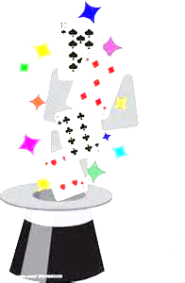

the day when it was the magician's turn to hand over his valuables. He turned out his pockets, which appeared to be empty. The pocket liners where in fact hiding his wallet, mobile phone and passport out of view of the thieves.
"Call it reverse pickpocketing," he told a Palm Beach area newspaper. "I had a gun pointing at my head from six inches away. I'm pretty good under pressure. But I had two young ladies with me."
When the robbers fled, Copperfield took down their license plate number and called the police. All four youths were arrested shortly thereafter.


dazzle v. 使目眩；使迷惑 application n. 應用；適用
hocus-pocus adj. 花招；騙人把戲 flair n. 新奇的創意

mugger n. 搶劫者 sleight-of-hand n. 巧妙手法
out of view 看不見 pickpocket v. 扒竊
license plate 車牌；牌照

