End to discrimination： Tunisian high school girls rebel against wearing uniforms

終止歧視：突尼西亞高中女生拒穿制服

In Tunisian high schools, girls are required to wear uniform, while boys are allowed to wear what they like. Now, the girls are up in arms.

One morning, instead of turning up for class wearing the regulation navy blue uniform, a defiant group of adolescent girls came to school in white T-shirts instead, demanding an "end to discrimination."
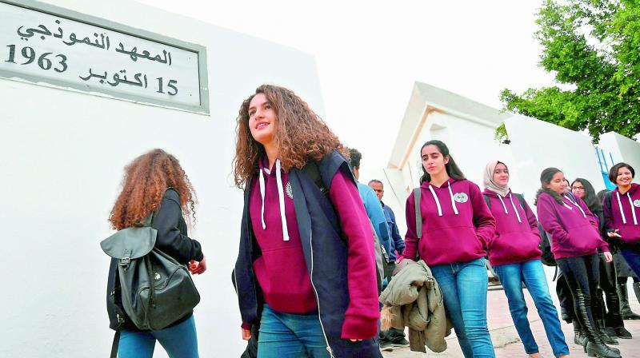

At the elite Bizerte public school in the north, as is the case in most high schools in the North African country, pupils have to sign a school rule stipulating that wearing a uniform applies to girls only.

One day in last September, supervisors reminded senior female students who did not abide by this rule that if they did not wear uniform, they would be sent home.

This "injustice" inspired many of the girls to take to social networks and vent their feelings. The girls agreed to take collective action from the following day. Several boys did the same, in solidarity with their classmates.

【Word Bank】
up in arms：慣用片語，竭力反對。
stipulate：動詞，規定。
vent：動詞，發洩感情。

取自《自由時報》http://iservice.ltn.com.tw/Service/english/english.php?engno=1185955&day=2018-03-22

