
Hotel splashes the cash with world’s 1st pure platinum bath

旅館斥資打造世界第一的純白金浴缸
Even the glistening gold of Donald Trump’s penthouse has got nothing on the latest accessory at a hotel in Chiba Prefecture, Japan － the world’s first pure-platinum bathtub, valued at 380 million yen.
The Ryugujo Spa Hotel Mikazuki Fujimitei has given the tub pride of place in its large observation bathroom on the 11th floor, from which Mount Fuji can be seen on clear days.
The hotel also boasts another bathtub made of 18-karat gold, valued at 290 million yen.
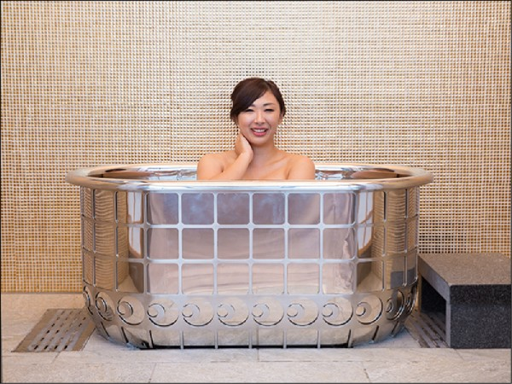

Both bathtubs were created by Tanaka Kikinzoku Jewelry KK and each measure 70 centimeters long, 120 cm wide and 65 cm tall. Some stainless steel was used to strengthen them.
The Hotel Mikazuki group runs four hotels, all featuring gold bathtubs, which have proved popular among visitors.

【WORD BANK】
have nothing on someone or something：
慣用語，沒有…來得好。
have/take pride of place：
慣用語，占據最重要地位。
boast：動詞，以擁有…（物）而自豪。

取自《自由時報》: http://iservice.ltn.com.tw/Service/english/english.php?engno=1152624&day=2017-11-17

